

**DIABETES MANAGEMENT SYSTEM**

INTR 8016 PROJECT RESEARCH PHASE



**Student ID:** R00076703

**Supervisor:** Noreen Gubbins

**Second Reader:** Meabh O’Connor

**Date:** 22 October 2014

**Version: 1.0**

**BSc (Hons) in IT Management**

**Department of Computing**

**Declaration**

I hereby certify that this material which I now submit for assessment, is entirely my own work and has not been taken from the work of others, save and to the extent, that such work has been cited and acknowledged within the text of my work.

I understand that my project documentation may be stored in the library at CIT, and may be referenced by others in the future.

**Signed: ­­­­­___________________________**  **Date:** **___________________**

**Table of Contents**

**PAGE**

**Executive Summary……………………………………… 4 – 4**

1. **Introduction…………………………………………………5 – 6** 
   1. Project Background**………………………………………**5 – 5
   2. Goals of the System**………………………………….**6 – 6
   3. Objective of the System**……………………………...**6 – 6
2. **Literature Survey…………………………………………7 – 41**
   1. Diabetes Mellitus**……………………………………**7 – 7
   2. The Impact of Diabetes**……………………………...**8 – 8
   3. Statistics about Diabetes**……………………………**9 – 10
   4. Types of Diabetes**…………………………………**11 – 13
      1. Type 1 Diabetes*..................11 – 12*
      2. Type 2 Diabetes*………….12 – 13*
   5. Symptoms of Diabetes**.............................................**14 – 14
   6. Diagnoses of Diabetes**..............................................**15 – 15
   7. Monitoring Diabetes**……………………………….**16 – 17
   8. Available Diabetes Applications**…………………..**18 – 40
   9. Conclusion**…………………………………………**41 – 41
3. **Project Requirements and Specification……....42 – 85** 
   1. The Stakeholders**……………………………………**42 – 42
   2. Project Constraints**………………………………….**43 – 43
   3. Relevant Facts and Assumptions**……………….......**43 – 43
   4. Product Boundary Use Case Diagram**……………...**44 – 45
   5. Project Use Case List**……………………………….**46 – 46
   6. Project Use Case Specifications**……………………**47 – 80
   7. Summary of Prototyping**…………………………....**81 – 82
      1. FunctionalRequirements*………….81 – 81*
      2. Non-Functional Requirements*……82 - 82*
   8. Data Dictionary**…………………………………….**83 – 84
   9. Business Data Model**……………………………….**85 – 85
4. **Project Design………………………………………....86 – 103** 
   1. Methodology**………………………………………**86 – 89
   2. Tools**……………………………………………….**90 – 90
   3. User Interface Design**…………………………….**91 – 103
5. **Project Plan……………………………………….…..104 – 105** 
   1. Work Break Down Structure**…………………………**104 – 105
6. **Conclusions…………………………………….……..106 – 107**
7. **Bibliography………………………………………....108 – 108**

**EXECUTIVE SUMMARY**

Over the past 50 years, there has been a dramatic increase in the prevalence of interrelated metabolic disease states, including obesity, insulin resistance, and type 2 diabetes. Diabetes Mellitus is a common condition that affects millions of people worldwide. For instance, if diabetes is not treated, it can lead to serious complications such as blindness, amputations, and even death. However, before people develop diabetes, they always develop pre-diabetes. Healthy people and people with pre-diabetes may be able to prevent or delay type 2 diabetes from developing.

In order to prevent the risks of serious complications that can be caused by diabetes, the blood glucose level must be monitored. The blood glucose level or blood sugar concentration is the amount of glucose (sugar) present in the blood of a human. Therefore, to monitor the blood glucose level in the blood an online application known as the **Diabetes Management System** (DMS) will be developed.

Diabetes Management System is a powerful and efficient way to track and monitor the management of diabetes over time. The system will be developed as an online application, where patients and doctors can track, monitor, and keep an accurate reading of blood glucose level tests.

The Diabetes Management System (DMS) will assist in the effective management of diabetes. It will provide a means of tracking, organising, and managing all of the activities involved in monitoring diabetes. DMS will work in parallel with the existing paper-based system i.e. the Diabetes Monitoring Diary. The DMS will make it possible to track patient’s data stored in the paper-based system. Moreover, the new system (DMS) can be used to replace the existing system (DMD), in order to make monitoring of diabetes easy for people with diabetes. See below.

**EXISTING** **NEW**

PAPER-BASED WEB-BASED

Mary Kate Mary Kate

**Existing System** – Diabetes Monitoring Dairy (DMD)

**New System** – Diabetes Management System (DMS)

1. **INTRODUCTION**
   1. PROJECT BACKGROUND

As a final year student in Information Technology Management (ITM), I undertake the effort to develop an interactive web-based Diabetes Management System. The application provides an easily-accessible means of managing an Endocrinology/Diabetes Clinic and its various Patients, Doctors and Nurses. This system is accessible by all stakeholders and mediates access via a security system. Diabetes Management System will transform the paper-based filling system i.e. Diabetes Monitoring Diary to a web-application system and enable simultaneous multi-user access to a central database.

My inspiration for the Diabetes Management System came from my Mum. She was recently diagnosed with TYPE 1 Diabetes. As a result of this, she needs to take insulin by injection and record the result of her blood glucose levels in her blood glucose testing record diary. The diary enables her to make the right adjustments to her insulin doses and keep a record of any appointments with her diabetes nurse or doctor.

Therefore in order to curb society’s risk for many serious health problems caused by Diabetes, I have decided to develop a **Diabetes Management System** (also known as the Diabetes Monitoring Application) for South Terrace Cork Hospital.

South Terrace Cork Hospital is the name of the business chosen to help gather more information on the requirement specifications needed for the Diabetes Management System. It is one of the leading diabetes clinics in Ireland, with the main clinic located in Northwood Business Campus Santry, Dublin 9 and seven other clinics located throughout Ireland. With the newly built System, the business will be able to provide an effective management of co-morbidities and diabetes for individuals and all groups at risk of developing health issues.

In addition, the system will be designed for hospitals and healthcare providers with the intention of preventing or delaying the short and long term complications caused by Diabetes. For instance, when a doctor defines a treatment plan for a diabetic based on his/her diabetes type, sex, age, etc. factors. The Diabetes Management System (DMS) can be used to send a reminder to patients to ensure better compliance with the treatment plan. And, once the patients, undergo tests, the data such as blood glucose level and insulin injections, is captured in the system. Then, doctors can view the progress of individual patient and take necessary interventions if needed.

* 1. GOALS OF THE SYSTEM
     1. The system will enable patients to enter their personal details, which will be saved to the Diabetes Management System database.
     2. The system will enable patients to keep track of their blood glucose level remotely. This process will reduce the time spent in filling out this information that is driven by the paper-based system i.e. the diabetes monitoring dairy.

With the Diabetes Management System, patients will be able to keep record of all their blood glucose level tests at any time.

* + 1. The system will be able to keep track of the patients’ insulin doses and any adjustments made by a doctor or nurse.
    2. The system will enable patients to update and view their personal information in real-time.
    3. The system will enable patients to leave comments and personal notes.
    4. The system will enable healthcare professionals to make appropriate insulin adjustments for their patients.
    5. The system will enable the secretary to register patients into the diabetes management system.
  1. OBJECTIVE OF THE SYSTEM
     1. The plan for the new system is to provide the capability for patients to update data in real-time. This process will reduce, if not eliminate some of the current problems that diabetic face – including blood glucose level test results that are out-of-date and incorrect information on the patients insulin injection dose.

In return, patients’ blood glucose level test results will be recorded in the system database, which will be up-to-date.

* + 1. To provide world ready diabetes management software that can be adapted to various web-browsers. The software will make diabetes management easier and more efficient than ever before.

* + 1. To aim is to design an online application that will be integrated into a mobile application. This application will help people with Type 1 diabetes and Type 2 diabetes manage the data associated with:

1. Records of actual insulin delivery
2. Statistical Evaluation
3. Coaching of dose corrections
4. Blood test results from a glucose meter.
5. Manual log entries for exercise and other factors.
6. **LITERATURE SURVEY**
   1. **DIABETES MELLITUS**

Diabetes Mellitus in today’s society is a health issue that affect more than 1 billion children, adolescence and adults globally, at least 300 million of adults clinically diabetic. Diabetes occurs as a result of inability of cells to use insulin properly and efficiently or insufficient production of insulin. In other words, it is a group of metabolic diseases characterized by high blood sugar (glucose) levels that result from defects in insulin secretion, or its action, or both. It was first identified as a disease associated with sweet urine and excessive muscle loss.

“A spoon full of insulin helps the sugar go down”.

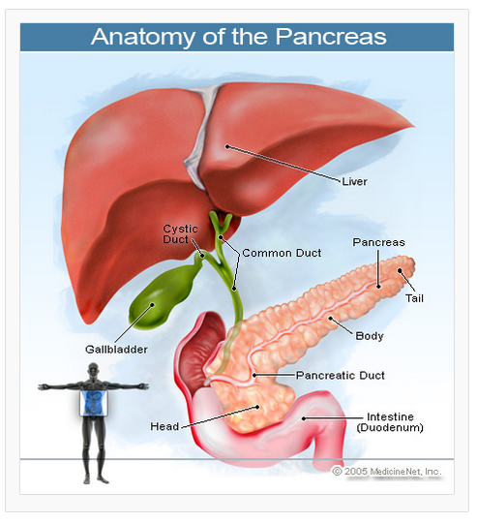

* 1. **THE IMPACT OF DIABETES**

Diabetes can cause some of the following health problems such as High Blood Pressure, Risk of Heart Disease or Heart Attack, Stroke, Amputations, Kidney Diseases, Blindness, Stomach and Bowel Problems, Sexual-function problems, Peripheral Neuropathy, Dizziness when Standing, Localized Nerve Failures and eventually can lead to Death.

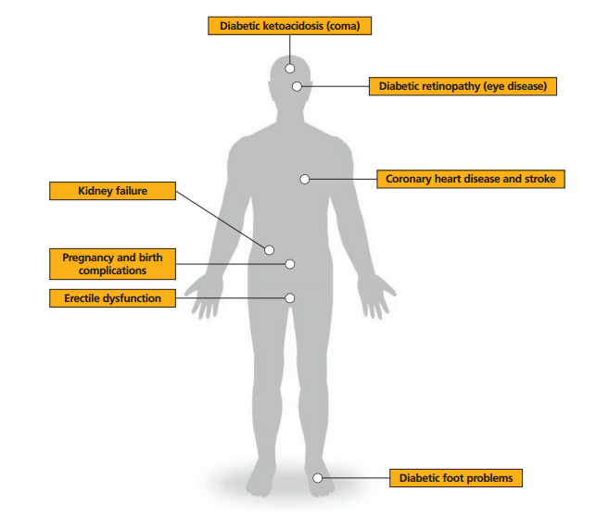

***The Complications of Diabetes***

* 1. **STATISTICS ABOUT DIABETES**

Diabetes Mellitus affects around 346 million people worldwide, and it’s the commonest metabolic illness globally. It is estimated that the total number of people living with diabetes in Ireland is 225,840. This figure will double by 2030 as estimated. In Ireland, it was estimated that 200,000 people had diabetes in 2003 and a further 200,000 had it but are unaware of the condition. The Diabetes Federation of Ireland estimated that a further 250,000 had pre-diabetes, and 50% are likely to develop diabetes in the ensuing five years if lifestyle changes were not considered.

According to the Diabetes Federation Diabetes Atlas (2013) 1, there are 207, 490 people with diabetes in Ireland in the 20 – 79 age group (with a 6.5% prevalence in the population). It is in line with former estimates that by 2020, there would be 233,000 people with the condition, and by 2030, there would be 278,850 people with the condition.

In 2005, the Institute of Public Health concluded that 4.7% of the population (circa 150,000) of the Republic had diabetes, with the highest prevalence in the Western Region which had 5.2%. However, in 2012, they revised their figures and now concluded that 9.6% of the population have Diabetes.

***The Economic Cost of Diabetes to Ireland***

During 1999, 10% of the national health budget was being consumed treating the condition. In other words, 49% on hospitalization for complications and wages, 8-9% on ambulatory care, 42% on drug costs, and attending non-diabetes specialists for diabetes related complications.

It is estimated that, there are 2,750 people under 20 years of age living with Type 1 diabetes. These results are based on young adults under the age of 20 attending transition clinics and the Irish Paediatric Diabetes Audit 20122 results.

It is estimated that about 90% of all diabetes is type 2 diabetes. The prevalence of type 2 diabetes in Ireland is increasing at an alarming rate in tandem with rising obesity rates. In Ireland, there are 15,600 people over 80 years of age living with Type 2 diabetes based on the TILDA study which showed a prevalence of 11.9% in the over 75 age group3.

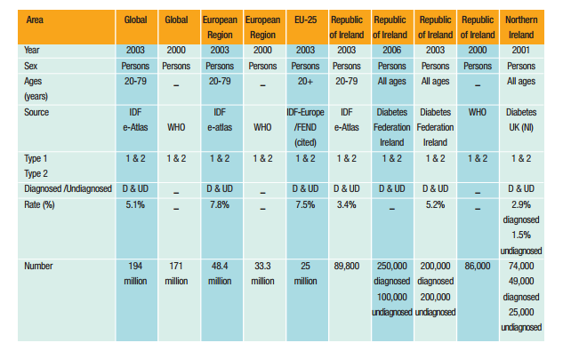

***This is the population Prevalence of Diabetes.***

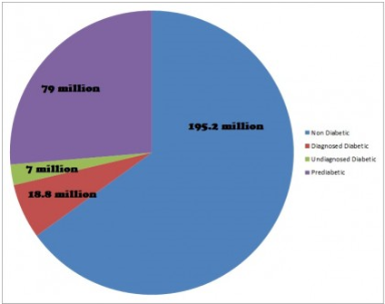

**Prediabetes, Diabetes Mellitus and Overall Numbers**

* 1. **TYPES OF DIABETES**

There are two main types of Diabetes Mellitus. These are **Type 1 Diabetes** and **Type 2 Diabetes**.

Type 1 diabetes was formerly known as Insulin Dependent Diabetes Mellitus (IDDM), or Juvenile Onset Diabetes Mellitus (JODM).

While, Type 2 diabetes was formerly known as Non-Insulin Dependent Diabetes Mellitus (NIDDM), or Adult Onset Diabetes Mellitus (AODM).

* + 1. **TYPE 1 DIABETES**

Type 1 diabetes occurs when the beta cells of the pancreas gland stop producing the hormone insulin. As a result, insulin by injection or through a pump is taken.

In type 1 diabetes, the beta cells of the pancreas, which are responsible for insulin production, are attacked by the misdirected immune system. The tendency to develop abnormal antibodies in type 1 diabetes is genetically inherited.

When a person is exposed to some viral infections such as Coxsackie viruses and Mumps, or other environmental toxins may trigger abnormal antibody responses that can cause damage to the pancreas cells where insulin is made. In type 1 diabetes, some of the antibodies seen include anti-glutamic decarboxylase antibodies, anti-islet cell antibodies and anti-insulin antibodies. In the majority of patients, these antibodies can be detected and helps determine which individuals are at risk of developing type 1 diabetes.

General screening of the population for type 1 diabetes is not recommended. Instead, high-risk individuals with type 1 diabetes such as those with a first-degree relative (parent or sibling) are screened.

Type 1 diabetes occurs in lean individuals, young, usually before thirty years of age, although, elderly patients do present with type 1 diabetes on occasion. The subgroup is referred to as LADA (Latent Autoimmune Diabetes in Adults).

Latent Autoimmune Diabetes in Adults is a slow, progressive form of type 1 diabetes. Only approximately 10% have type 1 diabetes, out of all the people with diabetes and the remaining 90% have type 2 diabetes.

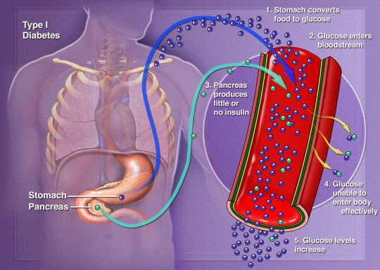

***Type 1 Diabetes***

* + 1. **TYPE 2 DIABETES**

Type 2 diabetes occurs when the body produces insulin, but do so relatively inadequately for the body’s needs especially, in the face of Insulin Resistance. In some cases, it means the pancreas produces larger than normal quantities of insulin.

A major feature of this form of diabetes is a lack of sensitivity to insulin by the cells of the body (particularly muscle cells and fat). Type 2 diabetes occurs mostly in individuals over 30 years old. However, there are an alarming number of patients with type 2 diabetes who are barley in their teen years. Majority of these cases are a direct result of lack of exercise, higher body weight, and poor eating habits.

Even though, there is a strong genetic component to developing type 2 diabetes, there are other risk factors such as obesity. The chances of developing diabetes are estimated to double for every 20% increase over desirable body weight.

The type 2 diabetes accounts for approximately 85%-90% of all cases of diabetes in European countries. Prevalence of Type 2 diabetes varies with sex, age and ethnic background and while there is a genetic susceptibility to Type 2 diabetes, environmental risks including nutritional factors, lack of physical activity, and central and overall obesity are also associated with increased risk.

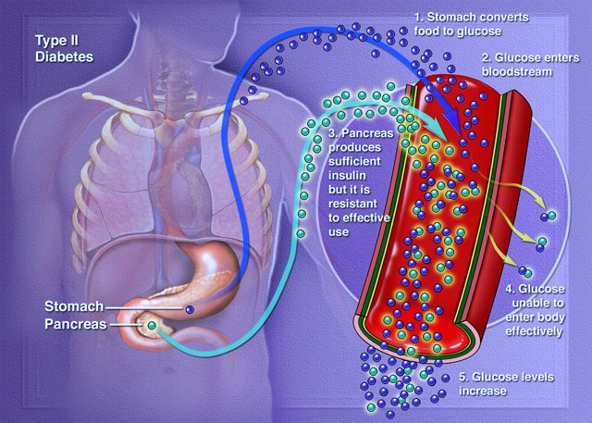

***Type 2 Diabetes***

* 1. **SYMPTOMS OF DIABETES**

The following are the signs and symptoms of diabetes:

* An absolute or relative insulin deficiency can lead to weight loss despite there is an increase in appetite.
* Fatigue, Vomiting and Nausea.
* People with diabetes are prone to develop infections of the bladder, skin, and vaginal areas.
* Slow- healing wounds
* Lack of interest and concentration.
* Increased hunger
* Excessive thirst
* Frequent Urination
* Tiredness
* A tingling sensation or numbness in the hands or feet.
* Fluctuations in blood glucose (sugar) levels can lead to blurred vision. While, extremely elevated blood glucose levels can lead to **lethargy** and **coma**.

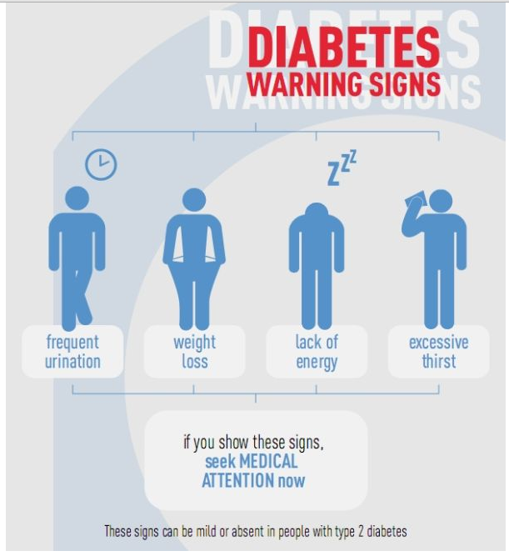

* 1. **DIAGNOSES OF DIABETES**

In order to diagnose diabetes, the preferred way is the fasting blood glucose (sugar) test. This is easy to perform and convenient. A single sample of blood is drawn and sent to a laboratory for analysis after the individual has fasted overnight (for at least 8 hours).

* The normal fasting plasma glucose levels are less than 100 milligrams per decilitre (mg/dl).
* Fasting plasma glucose levels of more than 126 mg/dl on two or more tests on different days indicate diabetes.
* While, a random blood glucose test can also be used to diagnose diabetes. A blood sugar level of 200 mg/dl or higher indicates diabetes.

Impaired fasting glucose (IFG) occurs when fasting blood glucose stays above 100mg/dl, but in the range of 100-126mg/dl.

Even though it is not routinely used anymore, OGTT (Oral Glucose Tolerance Test) is a gold standard for making the diagnosis of type 2 diabetes. It is commonly used for diagnosing gestational diabetes and in conditions of pre-diabetes, such as polycystic ovary syndrome.

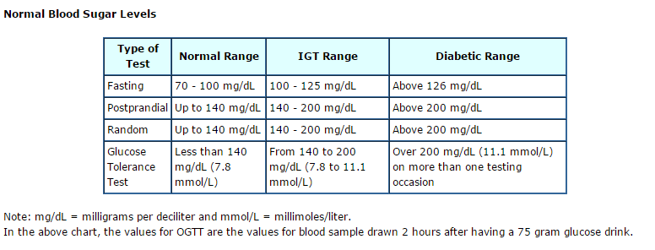

*The different types of Test for diagnosing diabetes*

* 1. **MONITORING DIABETES**

Blood Glucose Meter is the monitoring device used by people with diabetes mellitus or hypoglycaemia to measure and display the amount of sugar (glucose) in their blood. Their blood sugar (glucose) level can be affected by the food they eat, exercise, medications, stress and other factors.

Using a blood glucose meter helps diabetic patients to manage their diabetes better by tracking any fluctuations in their blood glucose level. The mark of a good meter is one that the patient will regularly use and that returns accurate and precise results.

The blood glucose meters, and other possible home medical devices that are available today for testing blood sugar levels are small, portable, and easy to use. Many types of blood glucose meters are available, from basic models to more-advanced meters with multiple features and options. Moreover, the cost of blood glucose test strips and blood glucose meters varies, as well as insurance coverage.

Over the past few years, the trend with blood glucose meters has been to maximize patient comfort and convenience by reducing the volume of the blood sample required. The blood sample size is now small enough that alternate-site testing is possible. As a result, it eliminates the need to obtain blood from the fingers and greatly reduces the pain associated with daily testing. Accurate and precise results have been increased by using better test strips, electronics, and advanced measurement algorithms. To name just a few, other conveniences include speedy results, edge fill strips, and illuminated test strip ports.

**Choosing the right blood glucose meter**

In order to use most blood glucose meters, patients have to first insert a test strip in the device. Then, they prick a clean fingertip with a special needle (lancet) to get a drop of blood. After, they carefully touch the test strip to the blood and wait for the blood glucose reading to appear on the screen of the device. The meter displays the level in units of mmol/l or mg/dl. Normally, blood glucose meters are accurate in how they measure glucose.

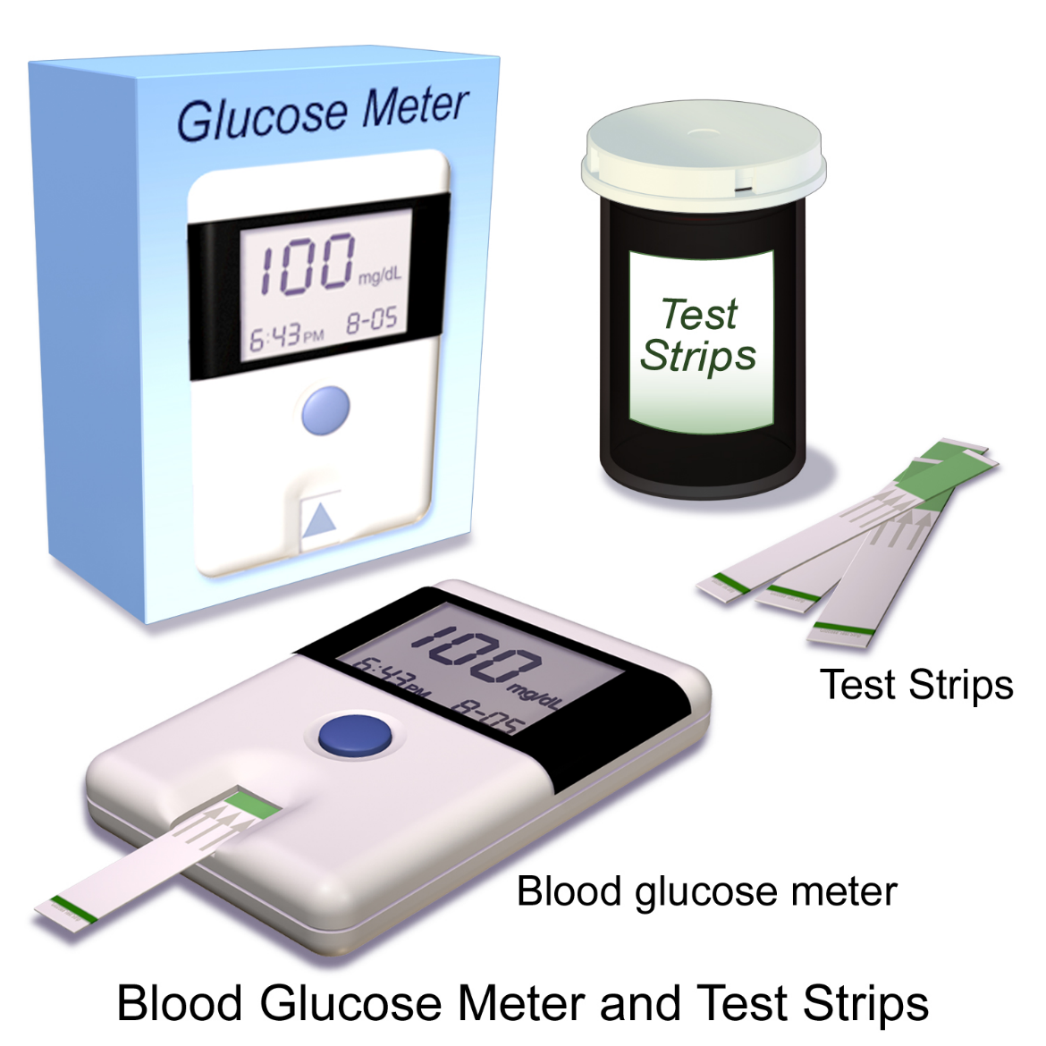

***Blood Glucose Meter and Test Strip used in monitoring Blood sugar (Glucose) Levels***

* 1. **AVAILABLE DIABETES APPLICATIONS**

Diabetes is a very complicated condition that requires patients to monitor their blood glucose and pay close attention to their diet and exercise.

There are best diabetes iPhone and Android Apps available that are used to measure or monitor blood glucose level. These apps are designed specifically for diabetes management and can save a lot of time and effort.

The following are the **top diabetes apps** that can be used to help get a handle on this chronic condition.

* + 1. **Fooducate**

Fooducate is an application that helps patients to identify which foods are high in fats, sugar, and unnecessary ingredients. Therefore, by scanning the barcodes, they will be able to learn more about the good and the bad in packaged foods.

Also, with an upgraded account, they can add in specifics about their personal health and health goals. Other premium features include tips and information about gluten and allergies. At the moment, additional features are in the works.

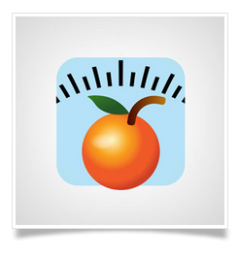 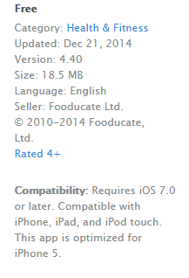

**Most important features of Fooducate:**

It analyses information found in product nutrition panels and ingredient lists. And, scan to discover things manufacturers don’t want people to notice:

* Excessive and added sugar
* Tricky trans fats
* High fructose corn syrup
* MSG
* Controversial food colourings
* GMO – Genetical Modified Organisms (Premium Feature)
* Additives and preservatives
* Artificial sweeteners such as aspartame
* And many more.

*Fooducate in both iPhone and Android*

**iPhone – 4.5 Stars – Free**

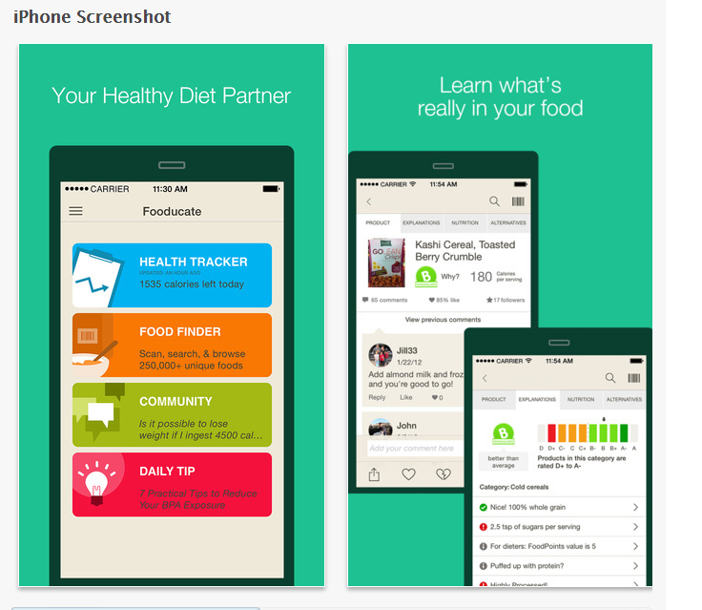

**Android – 4.3 Stars – Free**

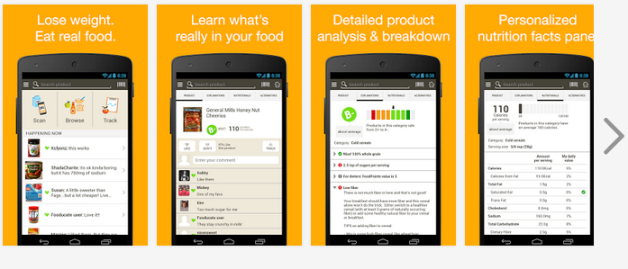

* + 1. **Glooko**

Glooko is an application designed to help the patient manage their diabetes. The Glooko application allows patients to upload their glucose readings directly from their meter. It enables them to create a record of their numbers so that the information is available to them at all times. Also, they can view the statistics breakdown anytime in graph form. The app enables the individual to track their goals and share the information with their doctor.

Additionally, the application has a food database that allows them to know more about the foods they eat. Also, to keep track of their diet, exercise routine, and medications. They can sync all their data and view it online as long as they are connected to the internet.

 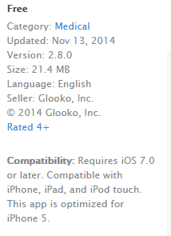

*Glooko in both iPhone and Android*

**iPhone – 4.5 Stars – Free**

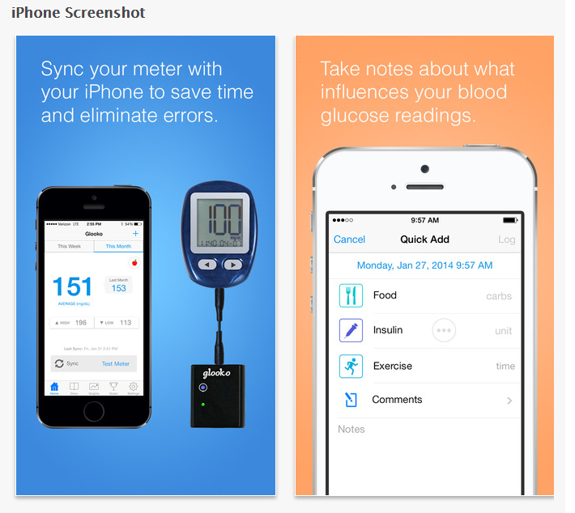

**Android – 4 Stars – Free**

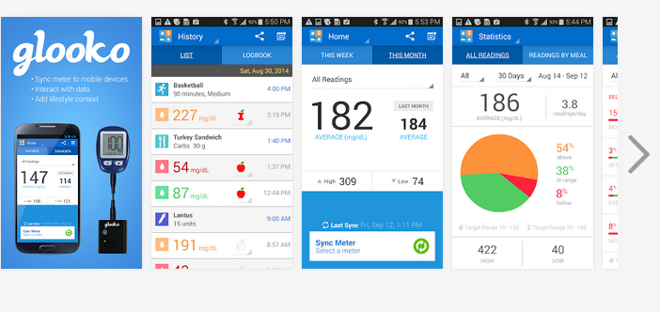

* + 1. **Diabetic Audio Recipes Lite**

Diabetic Audio Recipes Lite allows diabetes patients to find out the right ingredients they need to make food such as grilled salmon with dill sauce. It helps them to know the nutrition content of foods.

The application covers everything from appetizers to main dishes, side dishes, and desserts. Adjusting the font size or using the audio feature enables the individual to listen and cook at the same time. They can also add notes of their own to recipes.

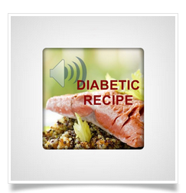

*Diabetic Audio Recipes Lite in both iPhone and Android*

**Android – 4 Stars – Free**

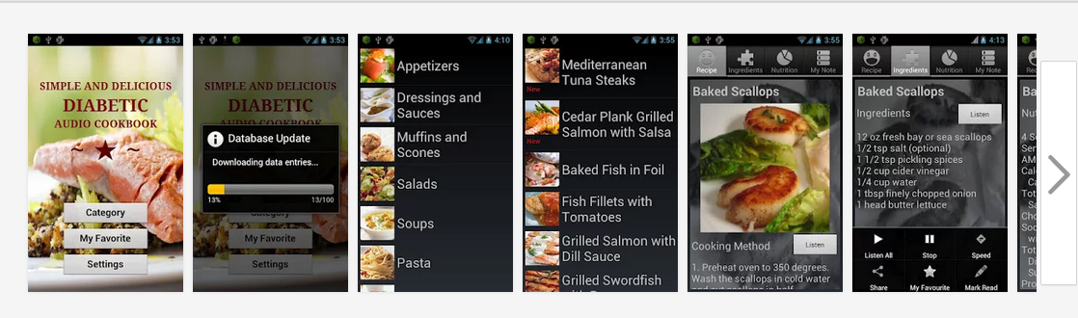

* + 1. **Diabetic Connect**

Diabetic Connect is an application that enables people with diabetes interact with fellow patients so that, they can talk, share tips, and learn together. It allows them to make personal connections, get and give support, and engage in meaningful conversations by following the activity feeds. It allows them to find out what others think of the latest diabetes treatments and management techniques. Therefore, with the application, they’re truly never alone.

 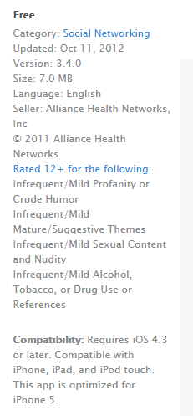

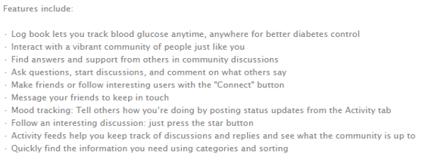

*Diabetic Connect in both iPhone and Android*

**iPhone – 5 Stars – Free**

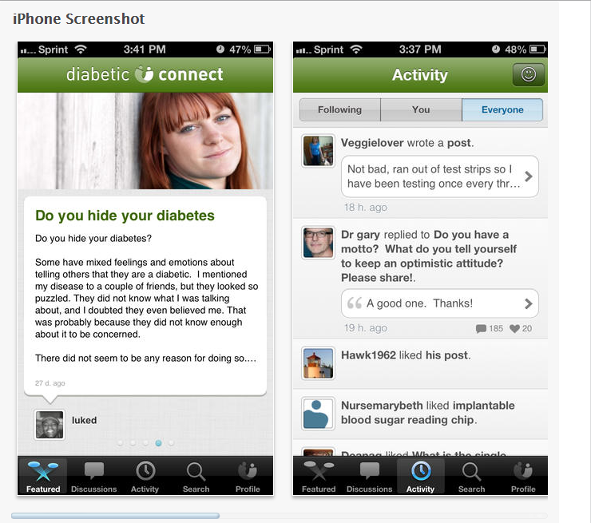

**Android – 3.9 Stars – Free**

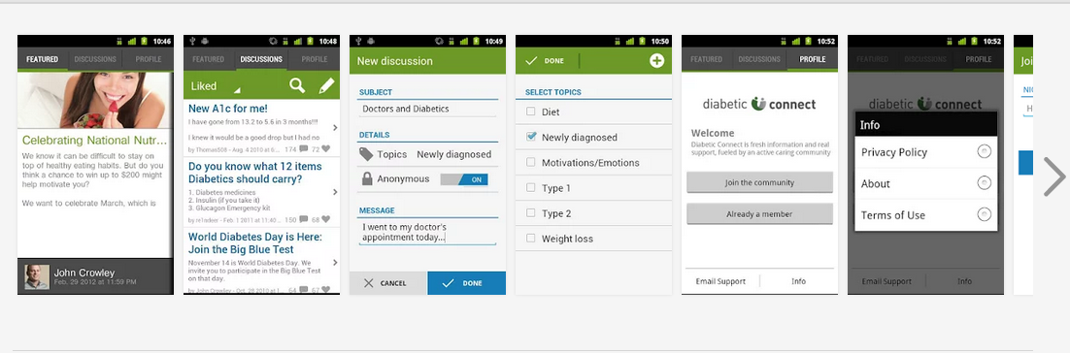

* + 1. **Glucose Buddy**

Glucose Buddy allows patients to store the data they need to manage diabetes without a lot of hassle. With embedded notifications, they can remember to log their numbers. Furthermore, they can input their glucose numbers, insulin dosages, and how many carbs they take in at each meal. Also, other features help them track their exercise, blood pressure, weight, and many more. They can sync their data so that they can view it online or even print it out. The clean design makes the application easy to understand and manage. Glucose Buddy is for a real “take-charge” person who values efficiency.

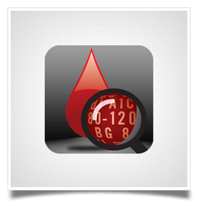 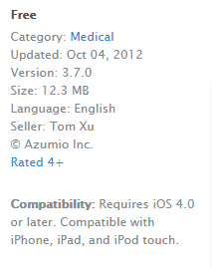

**Most important features found in Glucose Buddy are:**

* BG
* Medication (Insulin Dosages)
* Activities
* A1C
* Blood Pressure
* Weight
* Carbs (Food)

*Glucose Buddy in both iPhone and Android*

**iPhone – 4 Stars – Free**

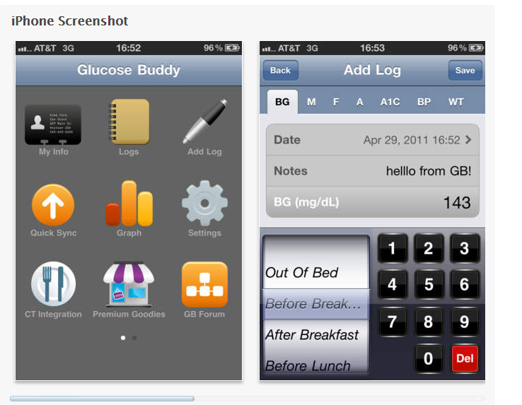

**Android – 4.4 Stars – Free**

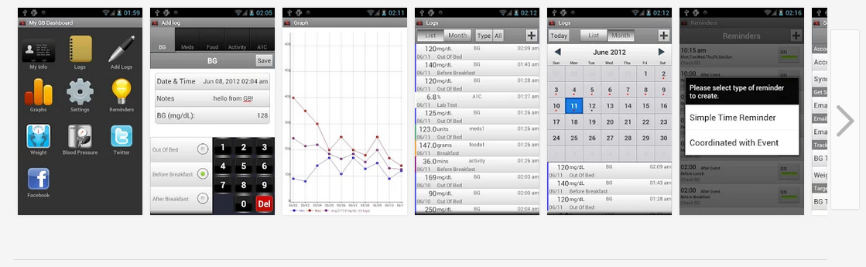

* + 1. **Diabetes App**

Diabetes App allows people living with diabetes to keep track of the things that may affect their blood sugar levels. This application can help them make informed choices about their diet and treatment.

Moreover, the convenient calendar feature embedded in this application gives them a quick overview of their important health information. Also, they don’t need to be online to take advantage of the vast food database. They can track their blood pressure, water intake, weight, and so much more. The options for backing up data, sharing through Twitter, and passcode protection make Diabetes App, a versatile tool for the person on the go.

 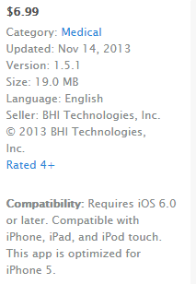

**Most important Features:**

* Log patients’ medications.
* Log patients’ insulin injections.
* Manage their activities and exercises.
* Manage glasses of water they consumed for the day.
* Track their weight and BMI changes.
* Blood pressure tracking.
* Retina display.
* Backup and restore over WiFi.
* Integrated with Twitter.
* Use passcode to protect their data.
* Support both US and SI units.

*Diabetes App in iPhone*

**iPhone – 4.5 Stars – Free**

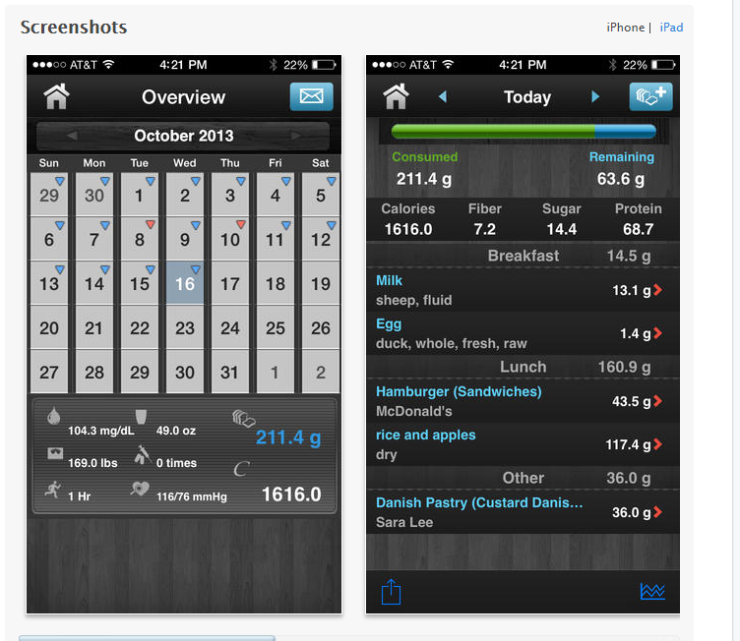

* + 1. **OnTrack Diabetes**

OnTrack Diabetes is an application that allows diabetes patients to easily and quickly keep track of everything they need to manage their diabetes.

**Most important Features includes:**

Its features include:

* Easily and quickly track blood glucose, haemoglobin A1c, food, weight and many others.
* Can add/edit categories to suit their needs.
* Generates detailed graphs and reports to share with their physician
* Supports both international and US units for glucose and haemoglobin A1c.
* Easily keeps track of their daily, weekly and monthly average glucose levels. And, set reminders to keep them on track.

The application makes diabetes management easier and quicker than ever. It contains an intuitive layout that enables them to put the information they need at their fingertips at all times. Still, it’s a lean, targeted approach to managing their health.

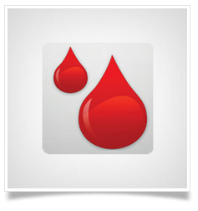

*OnTrack Diabetes in Android*

**Android – 4.4 Stars – Free**

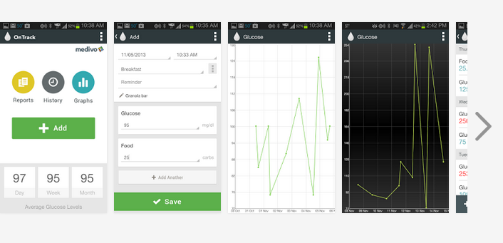

* + 1. **Dbees.com**

Dbees.com application helps people with diabetes to manage their insulin, insulin pump, medications, and diet. The application’s simple design means that, tracking their diabetes won’t cut into their busy schedule. It allows them to set reminders and access their data online. And, they can even send reports directly to their doctor.

 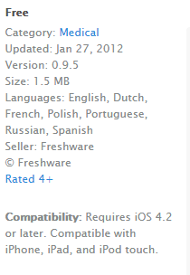

*Dbees.com in both iPhone and Android*

**iPhone – 5 Stars – Free**

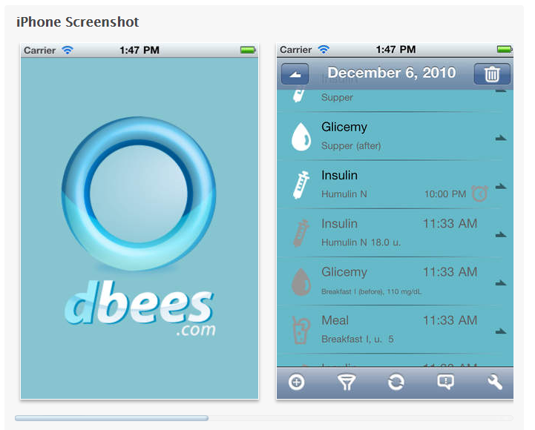

**Android – 4.1 Stars – Free**

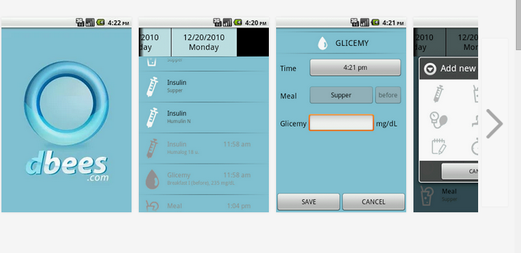

* + 1. **Glucool Diabetes**

The versatile Glucool Diabetes application lets patients customize diabetes management to fit their lifestyle and their carbs, insulin, and personalized notes quickly and efficiently. They’ll no longer have to rely on memory when they visit the doctor. The application also allows them to backup and restore their data, in order for them not to worry about losing all their records.

Moreover, the incredible graphing options embedded can pinpoint problems and show them what they’re doing right and where they’re going off course. The running record of their blood pressure, blood glucose levels, dietary intake, and medications will help them, and their doctor make important healthcare decisions with confidence.



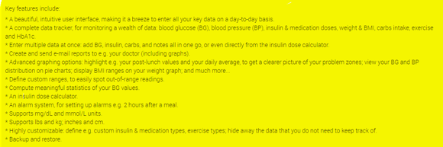

*Glucool Diabetes in Android*

**Android – 4.3 Stars – $4.99**

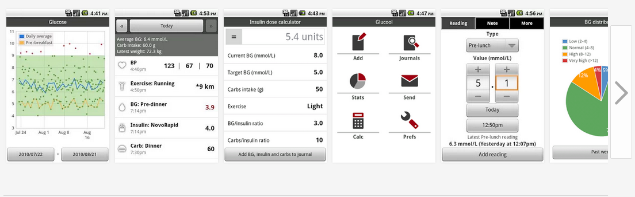

* + 1. **Diabetes Pilot**

Diabetes Pilot allows patients to scan a barcode to get the nutrition data on the foods they buy. However, they can also access information on a wide variety of foods. In addition, they can record their insulin and medication use, diet, exercise, and much more.

If the patient is an insulin user, Diabetes Pilot can also estimate how much they’ll need for a meal or what they need to get their numbers back on track. Even better, they’ll have a running record that they can share with their doctor and use for managing their diabetes from day to day.

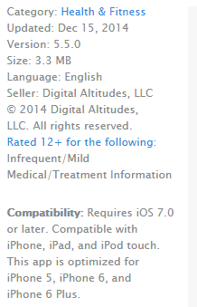

*Diabetes Pilot in iPhone*

**iPhone – 4 Stars – $11.99**

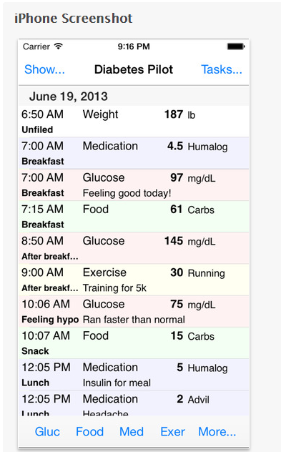

* + 1. **WaveSense Diabetes Manager**

The WaveSense Diabetes Manager application allows people with diabetes to gain access to a library of videos that can help them learn more about diabetes-friendly diets and how to make healthy lifestyle choices.

They simply input their information to keep tabs on their glucose counts and medications. The resulting charts and graphs help them get a clearer picture of what’s working for them and what’s not. With the application, it’s easy to share the information with their doctor. The patient can customize the application to reflect their mealtimes and other specifics to become their own diabetes manager.

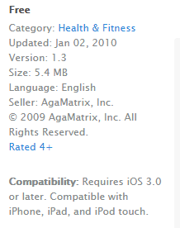

**The features of WaveSense Diabetes Manager includes:**

**LOGBOOK**

The glucose results are recorded by time of day.

**TREND CHART**

A visual representation of their glucose results over time.

**EMAIL REPORTS**

Email diabetes information to their family and trusted health care team for review. They choose what gets sent, to who, and when.

**COLOUR-CODED RESULTS**

Easily spot when they go into high or low ranges

**CARB/INSULIN TRACKING**

Record carb/insulin data as well as blood glucose results.

**FULLY CUSTOMIZABLE**

Set custom target ranges, hypo-/hyperglycemic limits, and mealtime schedules.

**TAGGING**

Allows them to put their glucose results in context by adding tags about food, exercise, medicine, or health issues.

**VIDEO CONTENT**

Award-winning video content courtesy of dLife.

*WaveSense Diabetes Manager in iPhone*

**iPhone – 3.5 Stars – Free**

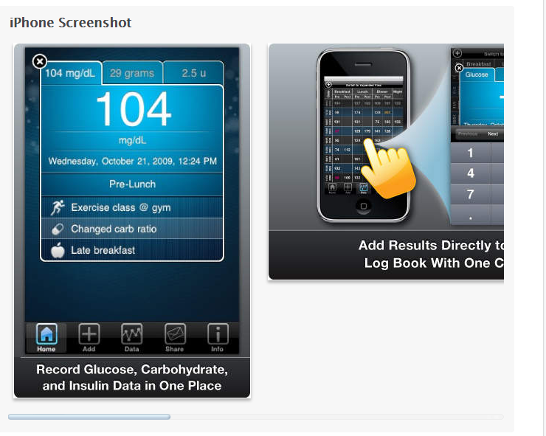

* 1. **CONCLUSION**

In conclusion, Diabetes Mellitus is a complicated condition that requires patients to monitor their blood glucose and pay close attention to diet and exercise.

Applications designed specifically for diabetes management can be used to save people with diabetes a lot of time and effort. The application is a good solution as it makes diabetes management easier and more efficient than ever before. The application will be an excellent tool in lightening patients load and making life a bit easier. Also, the application is free and inexpensive.

These diabetes apps are potential to aid people in managing diabetes in a number of ways. Moreover, additional factors that can be considered in selecting the applications listed above include: its user ratings, affordability, accessibility, format, functionality, and its relevance to diabetes and community’s needs. These iPhone and Android apps are designed to make diabetes more manageable.

1. **PROJECT REQUIREMENTS AND SPECIFICATION**
   1. **THE STAKEHOLDERS**
      1. The Client Dr Shirley Cotter, Manager of Diabetes Clinic Ltd.
      2. The Customer
         1. Manager
         2. Doctor
         3. Nurse
         4. Patient
         5. Secretary
      3. Other Stakeholders
         1. The Cork University Hospital
         2. The Diabetes Day Centre
         3. The Clinical Nutritionist
         4. The Eye Clinic
         5. The Diabetes Federation of Ireland
         6. The Diabetes Ireland Care Centre
      4. Maintenance Users and Service Technicians
         1. The Administrator
         2. IT Department Staff
   2. **PROJECT CONSTRAINTS**
      1. **Solution Constraints**

The product shall record patient’s blood glucose level, insulin injections, and blood pressure information and be able to retrieve the data to both the patient and the doctors’ clinic.

* + 1. **Integration Constraints**

Diabetes Management System shall provide an easily-accessible means of managing a Diabetes Clinic and its various patients, doctors, nurses, and secretary. The system is accessible by all users and mediates access via a security system.

The system enables simultaneous multi-user access to a secured central database.

* + 1. **Budget Constraints**

The budget for the project is €80,000, excluding costs incurred for attending regular meetings.

* + 1. **Schedule Constraints**

The system must be ready in 3 months, excluding the period of research. The software application must be implemented and tested before a final session of software testing. Furthermore, the application must work on majority of web-browsers such as **Internet Explorer**, **Google Chrome**, **Mozilla Firefox**, **Opera**, **Netscape**, and **Safari**, installed on any PCs with Windows, Vista, and Linux operating systems.

* 1. **Relevant Facts And Assumptions**
     1. **Relevant Facts**

Diabetes is now the commonest metabolic illness in the world. Meanwhile, Ireland has a growing population of Diabetes and is increasing at an alarming rate in tandem with rising obesity rates.

County Tipperary has the highest rate of diabetes people with 2.5% and County Kerry has the smallest number of diabetes people with 1%.

Moreover, research indicates that 9.6% of Irish population now have the disease. Diabetes increases the risk for many serious health problems such as Heart attack, Stroke, Kidney failure, Blindness, etc. However, with correct treatment and recommended lifestyle changes, many people with diabetes are able to prevent or delay the onset of complications.

* + 1. **Assumptions**

The graphical user interface (GUI) design must be available to the developers.

The chosen business must agree for the software to be developed by signing a contract.

* 1. **PRODUCT BOUNDARY USE CASE DIAGRAM**

The Product Scope diagram identifies the boundaries between the users (Actors) and the Product. This diagram is a summary of all the Product Use Cases.

The Diabetes Management System use case diagram illustrated below shows the actors/users outside the product boundary (i.e. the rectangle). While the product Use Cases (PUCs) are the ellipses inside the boundary. And, the lines denote interfaces between the Product and an Actor. The actors can be either automated or human.

The most important aspect in modelling a system is to capture the dynamic behaviour. In order to capture this, I used Visual Paradigm to model the system of our application. This use case diagram consists of the actors, use cases and their relationships.

The diagram below (**See next page**) is used to gather the functional and non-functional requirements of the Diabetes Management System.

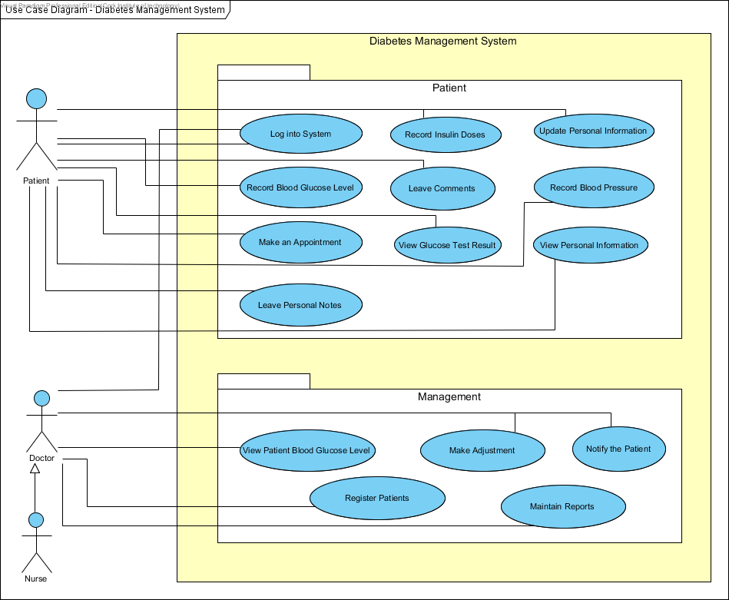

***Use Case Diagram for Diabetes Management System***

* 1. **PRODUCT USE CASE LIST**

|  |  |
| --- | --- |
| **Use-Case Name** | **Brief Summary of Each Use-Case** |
| Log into System | This use case describes the Login Process. |
| Update Personal Information | This use case describes the event of updating the Patient and Doctor Profile Information. |
| View Personal Information | This use case describes the event of viewing Patients complete Profile Information. |
| Record Blood Glucose Level | This use case describes the event of documenting Patient’s Blood Glucose Level. |
| Record Insulin Doses | This use case describes the event of documenting Patient’s Insulin Doses. |
| View Glucose Test Result | The use case describes the event of viewing blood glucose level tests. |
| Record Blood Pressure | This use case describes the event of documenting Patients’ blood pressure. |
| Make an Appointment | This use case describes the event of making an appointment to the Doctor/Nurse and keeping a record of any appointments with the Doctor. |
| Leave Personal Notes | This describes the process of leaving personal drafts, appointment dates, emergency contacts, etc. |
| Leave Comments | This use case describes the process of leaving special events/comments based on the Patient’s Blood Glucose Level measurement. |
| View Patient Blood Glucose Level Measurements | This use case describes the event of viewing Patient’s Blood Glucose Tests. |
| Register Patients | This use case describes the process of registering Patients into the system. |
| Make Adjustments | This use case describes the event of making adjustments to the Insulin Doses. |
| Notify Patients | This use case describes the event of notifying Patients to come in for Check-ups. |
| Maintain Reports | This use case describes the event of recording and maintaining any information such as Patient’s record of blood sugar readings, record of Insulin adjustments, record of blood pressure, list of Insulin doses, etc. Also, it includes adding and deleting reports. |

* 1. **PRODUCT USE CASES SPECIFICATIONS**

**Use-Case Specification: Login Use Case**

|  |  |  |
| --- | --- | --- |
| **Use-Case #** | **Use-Case Name** | **Use-Case Description** |
| **1** | **Log into System** | This use-case describes the Log in process |

***Brief Description***

This Use Case describes how a Patient, Doctor and a Nurse logs into the Diabetes Management System.

***Basic Flow of Events***

This Use Case starts when the actor wishes to Login to the Diabetes Management System.

1. The System requests that the actor enter his/her username and password.
2. The actor enters his/her username and password.
3. The System validates the entered username and password and logs the actor into the System.

***Alternative Flows***

**Invalid username/password**

If in the Basic Flow, the actor enters an invalid username and/or password, the system displays an Error Message. The actor can choose to either return to the beginning of the Basic Flow or cancel the login, at which point the use case ends.

***Subflows***

None

***Key Scenarios***

* Patient Login – This describes the process whereby a Patient wants to Log into the System.
* Doctor Login - This describes the process whereby a Doctor wants to Log into the System.
* Nurse Login - This describes the process whereby a Nurse wants to Log into the System.

***Preconditions***

None

***Post conditions***

If the use case was successful, the actor is now logged into the system. If not, the system state is unchanged.

***Extension Points***

None

***Special Requirements***

None

***Additional Information***

None

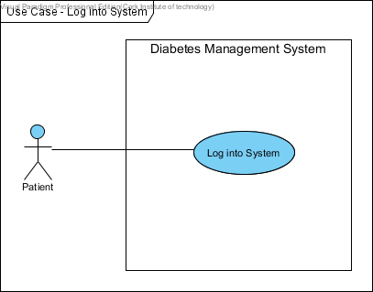

***Patient Log into System***

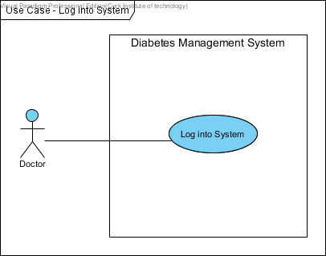

***Doctor Log into System***

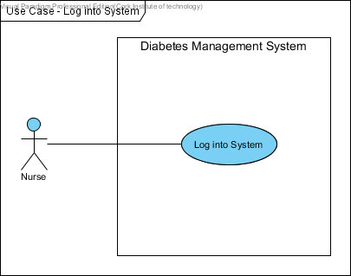

***Nurse Log into System***

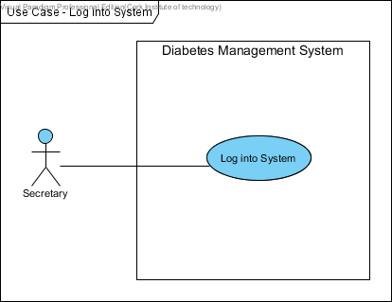

***Secretary Log into System***

**Use-Case Specification: Update Personal Information Use Case**

|  |  |  |
| --- | --- | --- |
| **Use-Case #** | **Use-Case Name** | **Use-Case Description** |
| **2** | **Update Personal Information** | This use-case describes the event of updating profile information. |

***Brief Description***

This use case describes how a patient update his/her personal Information in the Diabetes Management System.

***Basic Flow of Events***

This use case starts when the actor wishes to update personal information in the Diabetes Management System.

1. The system logs the actor into the system.
2. The system displays the actor’s personal profile.
3. The actor makes modification and saves his/her personal information.
4. The system validates, saves the information.
5. The system displays the updated personal information.

***Alternative Flows***

**Invalid username/password**

If in the Basic Flow, the actor enters an invalid username and/or password, the system displays an error message. The actor can choose to either return to the beginning of the Basic Flow or cancel the login, at which point the use case ends.

**Updated personal information unable to save**

If in the Basic Flow, the actor cannot save the updated information, the system may display a message saying the database is down. The actor can choose to update later when the database is up, at which point the use case ends.

***Sub flows***

None

***Key Scenarios***

* Patient updates personal information – This describes the process whereby a Patient wants to update his/her personal information in the system.
* Doctor updates personal information - This describes the process whereby a Doctor wants to update his/her personal information in the system.
* Nurse updates personal information - This describes the process whereby a Nurse wants to update personal information in the system.

***Preconditions***

The Patient, Doctor and Nurse must be registered in the system. And, the new system must be platform and accessible from remote areas. Also, it must be secured to prevent unauthorized change of data.

***Post conditions***

If the use case was successful, the actor’s personal information is updated in the system. If not, the system state is unchanged.

***Extension Points***

None

***Special Requirements***

None

***Additional Information***

None

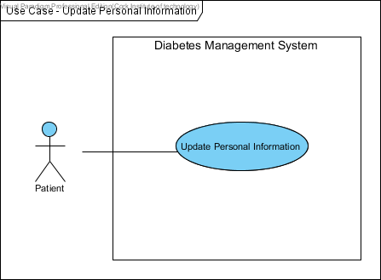

***Patient Update Personal Information***

**Use-Case Specification: View Personal Information Use Case**

|  |  |  |
| --- | --- | --- |
| **Use-Case #** | **Use-Case Name** | **Use-Case Description** |
| **3** | **View Personal Information** | This use case describes the event of patients viewing their profile information. |

***Brief Description***

This use case describes how a patient views their personal information in the Diabetes Management System.

***Basic Flow of Events***

This use case starts when the actor wishes to view his/ her personal information in the Diabetes Management System.

1. The actor is logged into the Diabetes Management System.
2. The system displays the actor’s personal profile.
3. The actor reviews their personal information.

***Alternative Flows***

**Not able to view personal information**

If in the **Basic Flow**, the actor cannot view his/her personal information, the system may display a message saying the system is unavailable. The actor can choose to cancel the viewing, at which point the use case ends.

**Requested Information Unavailable**

If in the **Basic Flow**, the requested information is unavailable, the system will display a message. The patient can choose to either return to the start of the Basic Flow or cancel the operation, at which point the use case ends.

***Sub flows***

None

***Key Scenarios***

* Patient views personal information – This describes the process whereby a patient wants to view their personal information in the system.

***Preconditions***

Patient information must exist and be up to date.

***Post conditions***

None

***Extension Points***

None

***Special Requirements***

None

***Additional Information***

None

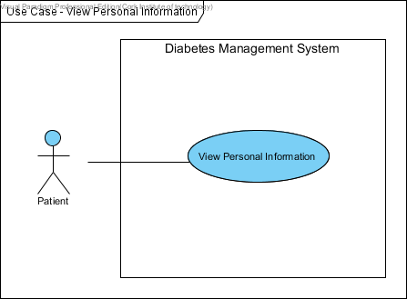

***Patient views Personal Information***

**Use-Case Specification: Record Blood Glucose Level Use Case**

|  |  |  |
| --- | --- | --- |
| **Use-Case #** | **Use-Case Name** | **Use-Case Description** |
| **4** | **Record Blood Glucose Level** | This use case describes the event of patients tracking their blood glucose level in the system. |

***Brief Description***

This use case describes how a patient record their blood glucose level in the Diabetes Management System.

***Basic Flow of Events***

This use case starts when the actor wishes to track his/ her blood glucose level in the Diabetes Management System.

1. The actor is logged into the Diabetes Management System.
2. The system requests that the Patient enters the blood glucose level (mmol/l) information. This includes: before breakfast, 2 hours after breakfast, before lunch, 2 hours after lunch, before dinner, 2 hours after dinner, before supper or bed, during the night.
3. Once the Patient provides the requested information, the system validates the information.
4. The patient’s blood glucose level readings is added into the system

***Alternative Flows***

**Invalid username/password**

If in the Basic Flow, the actor enters an invalid username and/or password, the system displays an error message. The actor can choose to either return to the beginning of the Basic Flow or cancel the login, at which point the use case ends.

**Blood glucose level reading** **unable to save**

If in the Basic Flow, the actor cannot save the blood glucose level readings, the system may display a message saying unable to save or database is down. The actor can choose to save later, at which point the use case ends.

**Invalid or Insufficient Information**

If in the **Basic Flow**, the patient has not provided sufficient information to record, the system will prompt the actor for the missing information. The patient can either enter the missing information or choose to cancel the operation, at which point the use case ends.

***Sub flows***

None

***Key Scenarios***

* Patient reads his/her blood glucose level – This describes the process whereby a patient wants to keep track of his/her blood glucose level in the system.

***Preconditions***

Patient must be known by the system in order for this use case to begin.

Blood glucose level (mmol/l) section must exist.

***Post conditions***

If the use case was successful, the patient’s blood glucose level readings is added to the system. If not, the system state is unchanged.

***Extension Points***

None

***Special Requirements***

None

***Additional Information***

None

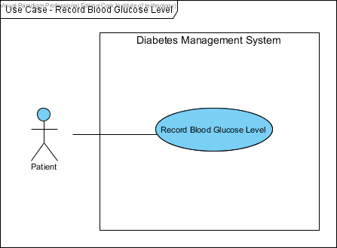

***Patient records blood glucose level***

**Use-Case Specification: Record Insulin Doses Use Case**

|  |  |  |
| --- | --- | --- |
| **Use-Case #** | **Use-Case Name** | **Use-Case Description** |
| **5** | **Record Insulin Doses** | This use case describes the process of keeping track of patient’s Insulin Doses. |

***Brief Description***

This use case describes how patients record their Insulin Doses in the Diabetes Management System.

***Basic Flow of Events***

This use case starts when the actor wishes to track his/ her Insulin Doses in the Diabetes Management System.

1. The actor is logged into the Diabetes Management System.
2. The system requests that the patient enters the Insulin Doses (units) information. This includes: types of insulin, pre-Breakfast (am), pre-Lunch (am), pre-Dinner (pm), before Bed (pm).
3. Once the patient provides the requested information, the system validates the information.
4. The patient’s Insulin Units is added into the system

***Alternative Flows***

**Invalid username/password**

If in the **Basic Flow**, the actor enters an invalid username and/or password, the system displays an error message. The actor can choose to either return to the beginning of the Basic Flow or cancel the login, at which point the use case ends.

**Insulin Units unable to save**

If in the **Basic Flow**, the actor cannot save the Insulin Injections (units given), the system may display a message saying unable to save to the database. The actor can choose to cancel the operation, at which point the use case ends.

**Invalid or Insufficient Information**

If in the **Basic Flow**, the patient has not provided sufficient information to record, the system will prompt the actor for the missing information. The patient can either enter the missing information or choose to cancel the operation, at which point the use case ends.

***Sub flows***

None

***Key Scenarios***

* Patient reads his/her Insulin Dose – This describes the process whereby a patient wants to keep track of his/her insulin Dose (units given) in the system.

***Preconditions***

Patient is known by the system.

Insulin Dose (Units Given) section must exist.

***Post conditions***

If the use case was successful, the patient’s insulin doses are added to the system. If not, the system state is unchanged.

***Extension Points***

None

***Special Requirements***

None

***Additional Information***

None

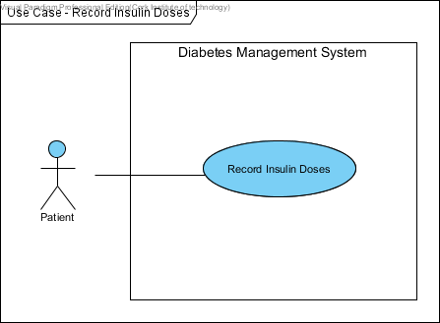

***Patient records Insulin Doses***

**Use-Case Specification: View Glucose Test Result Use Case**

|  |  |  |
| --- | --- | --- |
| **Use-Case #** | **Use-Case Name** | **Use-Case Description** |
| **6** | **View Glucose Test Result** | The use case describes the event of viewing blood glucose level tests. |

***Brief Description***

This use case allows the patient to view their glucose test results in the Diabetes Management System.

***Basic Flow of Events***

This use case is initiated when the actor wants to view their monthly blood glucose level results.

1. The system logs the actor into the system.
2. The system requests that the actor select the test period.
3. The system displays the actor’s blood glucose level test table.

1. The actor views the blood glucose level test table and analyses their blood glucose level performance.

***Alternative Flows***

**Invalid username/password**

If in the **Basic Flow**, the actor enters an invalid username and/or password, the system displays an error message. The actor can choose to either return to the beginning of the Basic Flow or cancel the login, at which point the use case ends.

**Not able to view their Glucose Test Results**

If in the **Basic Flow**, the actor cannot access the system to view their blood glucose test results, the system may display a message saying the system is down. The actor can choose to view the result table later when the system is back up, at which point the use case ends.

**Blood Glucose Level Test Results may be out of date**

Another alternative is if in the **Basic Flow**, the actor cannot view the up-to-date result for blood glucose test result. The actor can choose to view the performance table later when it’s updated, at which point the use case ends.

***Sub flows***

None

***Key Scenarios***

Patient views Blood Glucose Level Test Results – This describes the process of viewing blood glucose level test results.

***Preconditions***

Patience is known by the system.

Blood Glucose Level Test Results must exist.

***Post conditions***

None

***Extension Points***

None

***Special Requirements***

None

***Additional Information***

None

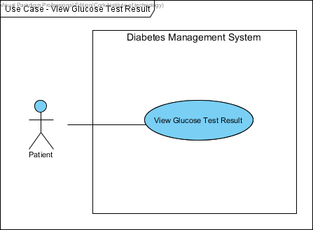

***Patient views Glucose Test Result***

**Use-Case Specification: Record Blood Pressure Use Case**

|  |  |  |
| --- | --- | --- |
| **Use-Case #** | **Use-Case Name** | **Use-Case Description** |
| **7** | **Record Blood Pressure** | The use case describes the event of keeping track of blood pressure. |

***Brief Description***

This use case describes how a patient keeps track of his/her blood pressure in the Diabetes Management System.

***Basic Flow of Events***

This use case starts when the actor wishes to record his/her blood pressure in the Diabetes Management System.

1. The actor is logged into the Diabetes Management System.
2. The system requests that the patient enters their blood pressure test result.
3. Once the patient provides the requested information, the system validates the information.
4. The patient’s blood pressure is added into the system

***Alternative Flows***

**Invalid username/password**

If in the **Basic Flow**, the actor enters an invalid username and/or password, the system displays an error message. The actor can choose to either return to the beginning of the Basic Flow or cancel the login, at which point the use case ends.

**Invalid or Insufficient Information**

If in the **Basic Flow**, the patient enters invalid information, the system will display an error message. The patient can either enter the valid information or choose to cancel the operation, at which point the use case ends.

***Sub flows***

None

***Key Scenarios***

* Patient reads his/her blood pressure – This describes the process whereby a patient wants to keep track of his/her blood pressure in the system.

***Preconditions***

The Patient must have previously logged onto the system.

Blood Pressure section must exist.

***Post conditions***

If the use case was successful, the patient’s blood pressure is added to the system. If not, the system state is unchanged.

***Extension Points***

None

***Special Requirements***

None

***Additional Information***

None

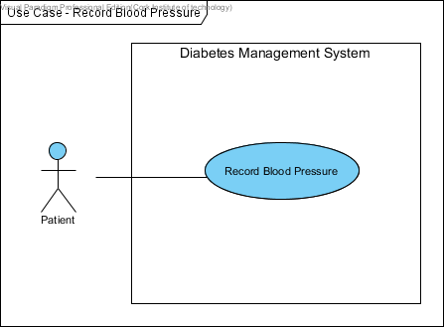

***Patient records Blood Pressure***

**Use-Case Specification: Make an Appointment Use Case**

|  |  |  |
| --- | --- | --- |
| **Use-Case #** | **Use-Case Name** | **Use-Case Description** |
| **8** | **Make an Appointment** | The use case describes the event of making an appointment. |

***Brief Description***

This use case describes how a patient makes an appointment.

***Basic Flow of Events***

This use case starts when the actor wishes to make an appointment in the Diabetes Management System.

1. The actor is logged into the Diabetes Management System.
2. The system requests that the patient provides the appointment date and time.
3. Once the patient provides the requested information, the system validates the information to see if the date and time is available for the individual.
4. Then, the system presents the actor with a confirmation screen.

***Alternative Flows***

**Invalid username/password**

If in the **Basic Flow**, the actor enters an invalid username and/or password, the system displays an error message. The actor can choose to either return to the beginning of the Basic Flow or cancel the login, at which point the use case ends.

**Appointment Date and Time not Available**

If in the **Basic Flow**, the chosen appointment date and time is not available, the system will display a message. The patient can either choose a different date and time or choose to cancel the operation, at which point the use case ends.

***Sub flows***

None

***Key Scenarios***

* Patient makes an appointment – This describes the process whereby a patient wants to make an appointment.

***Preconditions***

The Patient must have previously logged onto the system.

The appointment method must exist.

***Post conditions***

If the use case was successful, the patient’s appointment date and time is recorded in the system. Otherwise, the system state is unchanged.

***Extension Points***

None

***Special Requirements***

None

***Additional Information***

None

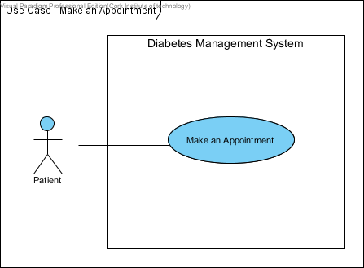

***Patient makes an Appointment***

**Use-Case Specification: Leave Personal Notes Use Case**

|  |  |  |
| --- | --- | --- |
| **Use-Case #** | **Use-Case Name** | **Use-Case Description** |
| **9** | **Leave Personal Notes** | This describes the event of leaving personal drafts, appointment dates, emergency contacts, etc. |

***Brief Description***

This use case allows a patient to leave personal notes. This includes personal drafts, appointment dates, emergency contacts, etc.

***Basic Flow of Events***

This use case starts when the patient wishes to leave personal notes in the Diabetes Management System.

1. The actor is logged into the Diabetes Management System.
2. The system requests that the patient specify the function he/she would like to perform. (either Add a note, Update a note, or Delete a note).
3. Once the patient provides the requested information, one of the sub-flows is executed.

If the patient selected “Add a Note”, the **Add a Note** sub-flow is executed.

If the patient selected “Update a Note”, the **Update a Note** sub-flow is executed.

If the patient selected “Delete a Note”, the **Delete a Note** sub-flow is executed.

***Sub flows***

* 1. **Add a Note** 
     1. The system requests that the patient enters personal note. This may include: personal drafts, appointment dates, emergency contacts or useful telephone numbers such as CUH Telephone Number, Diabetes Clinic Appointments, Diabetes Day Centre, Clinical Nutritionist (appointments), Podiatrist (appointments) Telephone Number, Eye Clinic (appointments), and Diabetes Federation of Ireland Telephone Numbers.
     2. Once the patient provides the requested information, the system saves and provides a confirmation screen. The personal note is then added to the system.
     3. The system displays the patient personal notes.

* 1. **Update a Note**
     1. The system requests that the patient enter the patient ID.
     2. The patient enters the patient ID. The system retrieves and displays the information notes.
     3. The patient makes the desired changes to the notes. This includes any of the information specified in the **Add a Note** sub-flow.
     4. Once the patient updates the necessary information, the system updates the personal note record with the updated information.
  2. **Delete a Note**
     1. The system requests that the patient specify the patient ID.
     2. The patient enters the patient ID. The system retrieves and displays the information notes.
     3. The system prompts the patient to confirm the deletion of the notes.
     4. The patient verifies the deletion.
     5. The system marks the notes for deletion and removes it from the system.

***Alternative Flows***

**Delete Cancelled**

If in the **Delete a Note** sub-flow, the patient decides not to delete the note, the delete is cancelled and the **Basic Flow** is re-started from the beginning, at which point the use case ends.

***Key Scenarios***

* Patient leaves Personal Notes – This describes the process whereby a patient wants to leave some Notes in the system.

***Preconditions***

The patient must be logged onto the system before this use case begins.

***Post conditions***

If the use case was successful, the patient’s personal notes is **added**, **updated**, or **deleted** from the system. Otherwise, the system state is unchanged.

***Extension Points***

None

***Special Requirements***

None

***Additional Information***

None

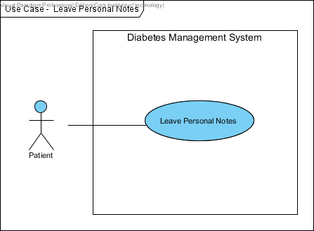

***Patient leaves Personal Notes***

**Use-Case Specification: Leave Comments Use Case**

|  |  |  |
| --- | --- | --- |
| **Use-Case #** | **Use-Case Name** | **Use-Case Description** |
| **10** | **Leave Comments** | This describes the event of leaving special events or comments. |

***Brief Description***

This use case allows a patient to leave special events or comments. This includes the events that happened after taking the insulin injection.

***Basic Flow of Events***

This use case starts when the patient wants to leave comments in the Diabetes Management System.

1. The actor is logged into the Diabetes Management System.
2. The system requests that the patient specify the function he/she would like to perform. (either Add a comment, Update a comment, or Delete a comment).
3. Once the patient provides the requested information, one of the sub-flows is executed.

If the patient selected “Add a Comment”, the **Add a Comment** sub-flow is executed.

If the patient selected “Update a Comment”, the **Update a Comment** sub-flow is executed.

If the patient selected “Delete a Comment”, the **Delete a Comment** sub-flow is executed.

***Sub flows***

* 1. **Add a Comment**
     1. The system requests that the patient enter his/her special events. This includes: an event that occurred after in the insulin injection.
     2. Once the patient provides the requested information, the system saves and provides a confirmation screen. The comments/ special events are then added to the system.
     3. The system displays the patient’s comments or events.
  2. **Update a Comment**
     1. The system requests that the patient enter his/her patient ID.
     2. The patient enters the ID. The system retrieves and displays the comments.
     3. The patient makes the desired changes to the comments. This includes any of the information specified in the **Add a** **Comment** sub-flow.
     4. Once the patient updates the necessary information, the system updates the special events/comments record with the updated information.
  3. **Delete a Comment**
     1. The system requests that the patient specify the patient ID.
     2. The patient enters the patient ID. The system retrieves and displays the comments.
     3. The system prompts the patient to confirm the deletion of the comments.
     4. The patient verifies the deletion.
     5. The system marks the comments for deletion and removes it from the system.

***Alternative Flows***

**Delete Cancelled**

If in the **Delete a Comment** sub-flow, the patient decides not to delete the comment, the delete is cancelled and the **Basic Flow** is re-started from the beginning, at which point the use case ends.

***Key Scenarios***

* Patient leaves Comments – This describes the process whereby a patient wants to leave special events/comments in the system.

***Preconditions***

The patient must be logged onto the system before this use case begins.

***Post conditions***

If the use case was successful, the patient’s special events/comments is **added**, **updated**, or **deleted** from the system. Otherwise, the system state is unchanged.

***Extension Points***

None

***Special Requirements***

None

***Additional Information***

None

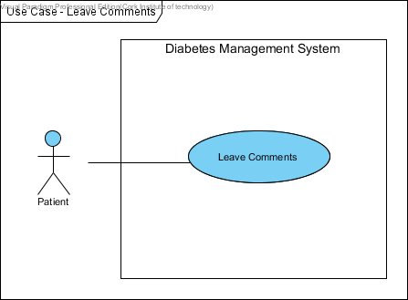

***Patient leaves Comments***

**Use-Case Specification: View Blood Glucose Level Measurements Use Case**

|  |  |  |
| --- | --- | --- |
| **Use-Case #** | **Use-Case Name** | **Use-Case Description** |
| **11** | **View Blood Glucose Level Measurements** | The use case describes the event of viewing Patient’s Blood Glucose Level Tests. |

***Brief Description***

This use case allows the Doctor to view patient’s blood glucose level measurements in the Health Management System.

***Basic Flow of Events***

This use case is initiated when the actor wants to view the patient’s blood glucose level measurements.

1. The system logs the actor into the system.
2. The system requests that the Doctor selects all the patients.
3. The system displays the selected patient blood glucose level measurements for the Doctor to analysis.

***Alternative Flows***

**Invalid username/password**

If in the **Basic Flow**, the actor enters an invalid username and/or password, the system displays an error message. The actor can choose to either return to the beginning of the Basic Flow or cancel the login, at which point the use case ends.

**System is down**

If in the **Basic Flow**, the system appears to be down, the system displays a message indicating that the system is down. The actor can choose to cancel the viewing and re-visit later, at which point the use case ends.

***Sub flows***

None

***Key Scenarios***

Doctor views Blood Glucose Level Measurements - This describes the process of viewing blood glucose level measurements.

***Preconditions***

Doctor must have previously logged onto the system.

Patient is known by the system.

Blood Glucose Level Measurements must exist.

***Post conditions***

None

***Extension Points***

None

***Special Requirements***

None

***Additional Information***

None

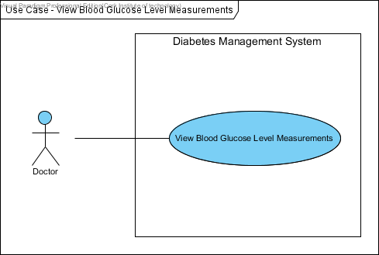

***Doctor views Blood Glucose Level Measurements***

**Use-Case Specification: Register Patients Use Case**

|  |  |  |
| --- | --- | --- |
| **Use-Case #** | **Use-Case Name** | **Use-Case Description** |
| **12** | **Register Patients** | This describes the process of registering Patients into the Diabetes Management System |

***Brief Description***

This use case describes how a Secretary registers Patients into the Diabetes Management System.

***Basic Flow of Events***

This use case starts when the actor wants to register a patient into the system.

1. The system logs the actor into the system.
2. The system requests that the Secretary enters the patient information. This includes: first name, last name, gender, address, telephone number, weight, height, BMI, date of birth (DOB), email address.
3. Once the Secretary provides the requested information, the system generates and assigns a username and password to the patient.
4. The patient is added to the system.
5. The system provides the patient with the new username and password via an automated email address.

***Alternative Flows***

**Invalid Patient Information**

If in the **Basic Flow**, the actor enters invalid details, the system displays an error message. The actor can choose to either enter the details again or cancel the registration, at which point the use case ends.

***Sub flows***

None

***Key Scenarios***

* Doctor registers Patients into the Diabetes Management System – This describes the process of registering Patients into the Diabetes Management System.

***Preconditions***

Doctor is known by the system.

Patients’ details must exit.

***Post conditions***

If the use case was successful, the patient is registered into the system. If not, the system state is unchanged.

***Extension Points***

None

***Special Requirements***

Doctor must get a system response within 10 seconds.

***Additional Information***

None

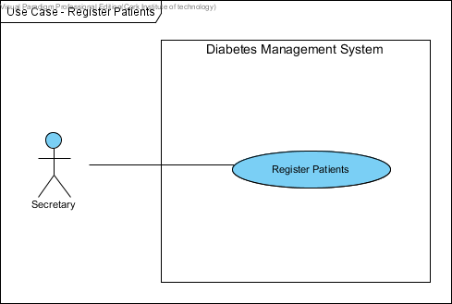

***Secretary registers Patients***

**Use-Case Specification: Make Adjustments Use Case**

|  |  |  |
| --- | --- | --- |
| **Use-Case #** | **Use-Case Name** | **Use-Case Description** |
| **13** | **Make Adjustments** | The use case describes the event of making an adjustment to the Insulin Doses. |

***Brief Description***

This use case describes how a Doctor makes adjustments to the patient’s Insulin Doses.

***Basic Flow of Events***

This use case starts when the actor wishes to make an adjustment to the Insulin Doses.

1. The actor is logged into the Diabetes Management System.
2. The system requests that the Doctor select the patient.
3. The Doctor makes the necessary adjustments to the patient’s Insulin Doses.
4. The system validates the information and presents the actor with a confirmation screen.

***Alternative Flows***

**Invalid username/password**

If in the **Basic Flow**, the actor enters an invalid username and/or password, the system displays an error message. The actor can choose to either return to the beginning of the Basic Flow or cancel the login, at which point the use case ends.

**Invalid Insulin Adjustments**

If in the **Basic Flow**, the actor enters invalid details, the system displays an error message. The actor can choose to either enter the data again or cancel the operation, at which point the use case ends.

***Sub flows***

None

***Key Scenarios***

* Doctor makes an adjustment to the patient’s Insulin Doses – This describes the process whereby a Doctor makes an adjustment to the patient’s Insulin Doses.

***Preconditions***

The Doctor must have previously logged onto the system.

Patient is known by the system.

Patient Insulin Injection Doses must exist and be up to date.

***Post conditions***

If the use case was successful, the patient’s Insulin Doses is adjusted and recorded in the system. Otherwise, the system state is unchanged.

***Extension Points***

None

***Special Requirements***

None

***Additional Information***

None

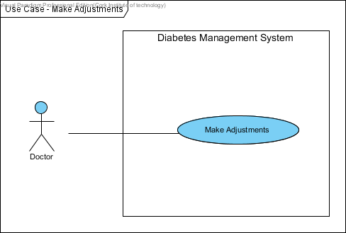

***Doctor makes Adjustments***

**Use-Case Specification: Notify Patients Use Case**

|  |  |  |
| --- | --- | --- |
| **Use-Case #** | **Use-Case Name** | **Use-Case Description** |
| **14** | **Notify Patients** | The use case describes the event of notifying Patients to come in for Check-ups. |

***Brief Description***

This use case allows the Doctor to notify a patient when he/she sees that the patient is in danger according to their blood glucose level test results.

***Basic Flow of Events***

This use case is initiated when the actor wants to notify the patient to come in for check-ups.

1. The system logs the actor into the system.
2. The system displays the patient’s blood glucose level test results.
3. The actor reviews the results and notifies the patient to come in for a check-up.

***Alternative Flows***

**Invalid username/password**

If in the **Basic Flow**, the actor enters an invalid username and/or password, the system displays an error message. The actor can choose to either return to the beginning of the Basic Flow or cancel the login, at which point the use case ends.

**Notification Cancelled**

If in the **Basic Flow**, the actor does not want to notify the patient, the actor can choose to cancel the notification, at which point the use case ends.

***Sub flows***

None

***Key Scenarios***

Doctor notify Patients – This describes the process of notifying a patient to come in for check-up.

***Preconditions***

Doctor must have previously logged onto the system.

Patient is known by the system.

Patient’s Blood Glucose Level Measurements must exist and be up to date.

***Post conditions***

If the use case was successful, the patient is notified to come in for a check-up. Otherwise, the system state is unchanged.

***Extension Points***

None

***Special Requirements***

None

***Additional Information***

None

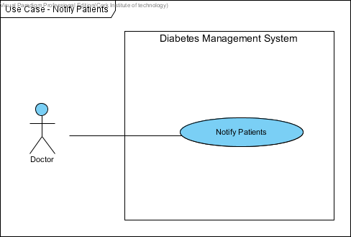

***Doctor notifies Patients***

**Use-Case Specification: Maintain Reports Use Case**

|  |  |  |
| --- | --- | --- |
| **Use-Case #** | **Use-Case Name** | **Use-Case Description** |
| **15** | **Maintain Reports** | This use case describes the event of recording and maintaining any information such as Patient’s record of blood sugar readings, record of Insulin adjustments, record of blood pressure, list of Insulin doses, etc. Also, it includes adding and deleting reports. |

***Brief Description***

This use case allows the Doctor to create either “patients’ blood sugar readings,” “record of Insulin adjustments,” “record of Insulin Injections,” and/or “personal information” report. The Doctor can also delete reports from the system.

***Basic Flow of Events***

The use case begins when the Doctor requests that the system create a Patients report.

1. The system logs the Doctor into the system.
2. The system requests that the Doctor specify the following report criteria:

Report Type (either blood glucose level information, insulin units or blood pressure),

Begin and end dates for the report,

Patient name(s)

1. Once the Doctor provides the requested information, one of the sub-flows is executed.

If the Doctor selected “Add a Report,” the **Add a Report** sub-flow is executed.

If the Doctor selected “Delete a Report,” the **Delete a Report** sub-flow is executed.

***Sub flows***

* 1. **Add a Report** 
     1. The system provides the Doctor with a report satisfying the report criteria.
     2. The Doctor may then request that the system save the report. At which time, the system requests the Doctor to provide the name and location for saving the report.
     3. Once the Doctor provides the requested information and confirms the decision to save the report, the system saves the report to the specified name and location.
     4. If by any chance, the Doctor did not select to save the reports, the report is discarded.
  2. **Delete a Report**
     1. The system requests that the Doctor selects the report.
     2. The system retrieves and displays the report information.
     3. The system prompts the Doctor to confirm the deletion of the report.
     4. The Doctor verifies the deletion.
     5. The system marks the report record for deletion and removes the report from the system.

***Alternative Flows***

**Invalid username/password**

If in the **Basic Flow**, the actor enters an invalid username and/or password, the system displays an error message. The actor can choose to either return to the start of the **Basic Flow** or cancel the login, at which point the use case ends.

**Delete Cancelled**

If in the **Delete a Report** sub-flow, the Doctor decides not to delete the report, the delete is cancelled and the **Basic Flow** is re-started at the beginning, at which point the use case ends.

**Invalid Format or Insufficient Information**

If in the **Basic Flow**, the Doctor has not specified sufficient information to create the selected report, the system will prompt the actor for the missing information. The Doctor can either enter the missing information or choose to cancel the operation, at which point the use case ends.

**Requested Information Unavailable**

If in the **Basic Flow**, the requested information is unavailable, the system will display a message. The Doctor can choose to either return to the start of the **Basic Flow**, or cancel the operation, at which point the use case ends.

***Key Scenarios***

Doctor creates reports – This describes the process of creating patients’ reports.

***Preconditions***

The Doctor must be logged onto the system in order for this use case to begin.

Patients must exist and their information must be up to date in the system.

***Post conditions***

The system state is unchanged.

***Extension Points***

None

***Special Requirements***

None

***Additional Information***

None

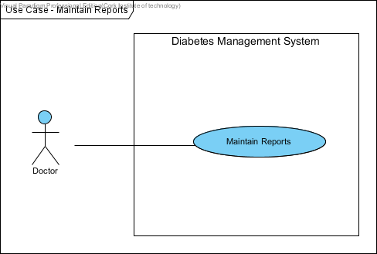

***Doctor maintains Reports***

* 1. Summary of Prototyping
     1. **Functional Requirements** 
        1. The system shall allow the Patient and Doctor to log in with their username and password.
        2. The system shall enable the Patient to view their Personal Information.
        3. The system shall allow the Patient to update their Personal Information.
        4. The system shall enable the Patient to view their Glucose Test Results.
        5. The system shall record Patient Insulin Doses.
        6. The system shall record Patient Blood Glucose Level.
        7. The system shall record Patient Blood Pressure.
        8. The system shall allow the Patient to make an appointment.
        9. The system shall allow the Patient to leave Personal Notes.
        10. The system shall allow the Patient to leave Comments.
        11. The system shall enable the Doctor to view the Patient Blood Glucose Level Measurements.
        12. The system shall allow the Doctor to register Patients into the system.
        13. The system shall allow the Doctor to make adjustments.
        14. The system shall allow the Doctor to notify Patients.
        15. The system shall enable the Doctor to maintain Reports.
        16. The system shall enable copies of Patient Information, Blood Glucose Level tests to be printed.
     2. **Non-Functional Requirements** 
        1. **Operational Requirements**
           1. The system shall run on web browsers, desktop PCs and mobile devices, to be used by stakeholders.
           2. The system shall interface with the business management system.
           3. The system shall be flexible and easily adaptable to changes, saving up to 50 percent of its operating cost.
           4. The system shall be a platform and accessible from any web browsers, mobiles and from any remote areas.
        2. **Performance Requirements**
           1. The system shall support management staff of approximately 150 management people.
           2. The system shall enable patients to update their personal information and blood glucose level results within 2 minutes.
           3. The user shall get a system response within 10 seconds.
           4. The Doctor shall be able to register up to 100 diabetic patients in the system.
           5. Responses to report queries shall take less than two seconds.
        3. **Security Requirements**
           1. No patient can access any other patient’s personal information or blood glucose results.
           2. The system shall be secured to prevent unauthorized access of patient data.
        4. **Availability Requirements**
           1. Information about blood glucose results shall be available at any time to the patients.
           2. A list of diabetic patients shall be made available at any time to the Doctor.
  2. **DATA DICTIONARY**

This data dictionary is a textual list of all concepts that are defined during the analysis. The aim of the data dictionary is to define a vocabulary that will be common to all the users of the Diabetes Management System.

|  |  |
| --- | --- |
| **Name** | **Description** |
| **Patient ID** | This is a unique automated Identification Number, which is assigned to each patient when registered by the system. This will enable them to log in into the system. |
| **Username** | This is an Identification Name of the user account name. This can be combination of the user names and any other names or special characters the account will know. |
| **Password** | The password enforces the privacy’s of the users account. It is used by the user to log into the System. |
| **First Name** | The first name of the users as known to the System. |
| **Last Name** | The user’s last name as known to the System. |
| **Address** | This is the current postal address of the users, These are mostly the home or office address of the user. |
| **Phone Number** | This is the contact phone number of the user. |
| **Email Address** | This is active and current email address of the user. The system uses automate email to send password to the user on registration. |
| **DOB** | DOB is the date of birth of the users. |
| **Gender** | It is the sex of the user of the application. |
| **Diabetes** | This is a disorder of the metabolism causing excessive thirst and the production of large amounts of urine. |
| **Height** | This is the height of the patient. |
| **Kgs** | This measure the unit of the weight. |
| **BMI**  **(Body Mass Index)** | This is to calculate the body mass of the patient. It is calculated by the formula: ((weight * 703)/ (height * height)). The gauge is used to determine whether or not a person is overweight or obese. |
| **Medical History** | This is the medical history of the patient such as: Allergies, heart condition and general patient’s health status. |
| **Blood Pressure** | This is the pressure of the blood in the circulatory system. Also, it is measured for diagnosis since it is closely related to the force and rate of the heartbeat and the diameter and elasticity of the arterial walls. |
| **Blood Glucose Level** | This is the amount of glucose in the blood. Glucose is a sugar that comes from the foods we eat and it’s also formed and stored inside the body. |
| **Insulin Doses** | This is the number of Units given in each injection (Pre-Breakfast, Pre-Lunch, Pre-Dinner, and Before Bed). |
| **Comments** | These are special events that happen when the patient takes the insulin injections. The patient can leave comments such as: “hype during the night”. |
| **Personal Notes** | This is some text written by the patient that can contain information such as appointment dates, checklist of for diabetes day care unit. It is updated frequently. |
| **Image** | This is a picture of the user. |
| **Aerobic Exercise** | Activity involving large muscles, done for an extended period of time. Aerobic exercise can be used for weight loss. Examples of aerobic exercise include walking, biking, jogging, swimming, aerobic classes and cross country skiing. This information may be used via ‘Tips’ that are shown on the form when a member logs on. These are randomly generated from a list of tips on the server. |
| **Database Security** | Connecting directly to a database leaves the system vulnerable to hackers. We reference ‘Database Security’ as connecting to our database by first sending our information through a script and then to the database. |
| **Database** | This is where data is stored in the system such as patients’ data. |
| **Doctor** | This is a user that is qualified to treat people who are ill. Doctor can notify patient when their blood sugar level readings are low. |
| **Nurse** | This is someone trained to take care of the sick or infirm especially in a hospital. |
| **Patient** | A user of the system that can view and update their statistics. |
| **User ID** | Special number to identify the different users of the system. |
| **Log on** | An interface where the user must input their username and password before they can use the application. It is the bridge between the system and the users. |
| **Performance Graph / Light** | A graph representation to illustrate patients’ blood sugar level performance. |
| **Register Screen** | When the patient details are entered into the system, they are then registered in the system. |
| **Diabetic Patient** | A person that has diabetes. |

* 1. **BUSINESS DATA MODEL**

**Class Diagrams**

Class Diagrams in UML (Unified Modelling Language) is a static diagram that describes the structure of the Diabetes Management System being modelled. It shows a collection of the System’s Classes (i.e. Class Names), their Attributes, Operations, and the Relationships among Objects. Moreover, it is the main building block of object-oriented modelling. Class diagrams can be used to illustrate data model of the Diabetes Management System.

Class Diagrams will be used to model the general static view of the Diabetes Management System and detailed modelling that translate the models into programming codes.

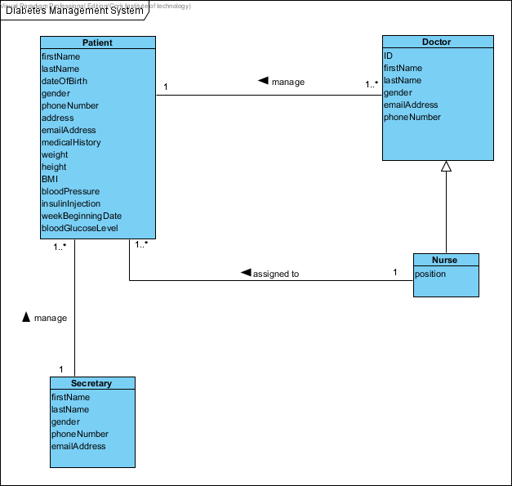

***Domain/Conceptual Model for Diabetes Management System***

1. **PROJECT DESIGN**
   1. **METHODOLOGY**

In order to produce a world ready application, a combination of iterative and prototype-based development **methodologies** will be used during the development of Diabetes Management System.

The **tools** that will enable the process for the completion of the project are as follows:

**Revision Control Software**

The revision control software also known as the source control software is a management tool used to help build better software and also provide a great opportunity to work efficiently. GitHub is an instance of a hosting service that uses the Git revision control system. GitHub is a powerful mechanism tool that provides numerous features, which makes teamwork and code management effortless. Moreover, it is a web-based hosting service for software projects.

The basic unit of work in GitHub is the **commit**. A commit is a code change with an accompanying comment by its author. Whenever a change takes place, the details are immediately published on the GitHub website: who made the changes, when it was made, what lines were changed, and many more. And a comprehensive history maintained with all the details of the changes made in an easily accessible way.

An example of this is shown below:

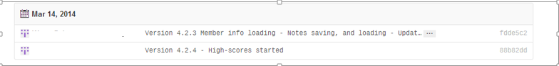

*Commits published on GitHub*

A collection of source code and its associated history is called a **repository** also known as **‘repo’** in GitHub. In order words, creating a repository gives anyone full access, makes it possible for the individual to make necessary changes at their spare time by **pushing** commits to the Git. And, receives updates with new changes by **fetching** from the GitHub. In addition, these are simple commands triggered by a button press in the development tools.

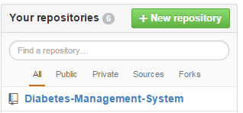

*Repository created on GitHub*

One of Git’s most important features is the ability to create ***branches***. Branches in GitHub are concurrent lines of development independent of the ‘**master**’ code, in which changes can be made without the fear of interference. New branch can be created for each feature, and have a single member work on one or two branches at a time. Therefore, if a feature does not work out, it can only be abandoned with no consequences. This process encourages rapid experimentation and development of the project.

The most helpful feature of GitHub is ***merging***. When a feature is completed and tested, its branch can be merged back into the master branch to integrate the changes into it. The process of merging is mostly automatic, and conflicts are easily resolved manually. Because branches diverge from the master codebase, over time they grow out of sync as other work is completed and integrated. But merging the work in both ways (i.e. by merging the master branch into the feature branch), it can be brought up to the date with the latest changes, without any interference to the main codebase. This capability completely solves the problem of combining code from multiple contributors, which otherwise would have been a massive issue during development.

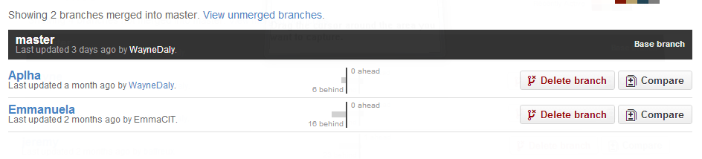

*Branches created and merged into master within our Repository on GitHub*

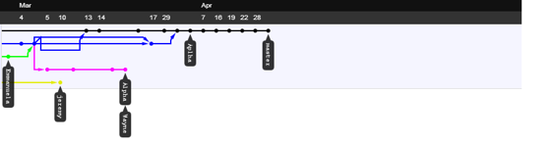

*An excerpt from repository history:* ***dots are commits, lines are branches, and arrows signify merges***

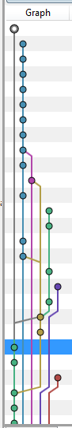

*An excerpt from source Tree history: dots are commits, lines are branches*

In conclusion, Git solves almost every technical issue involved with team-based development. GitHub provides an issue-tracking system which is integrated with the commit log. This will be used to keep track of bugs founded and to specify the features needed. Whenever an issue is created, it is notified by email. The issue tracker is also integrated with the commit history – commits can be marked as related to a given issue and they show up on the issue page on the website. This will make it very easy to see what is done about each problem as they are encountered and fixed.

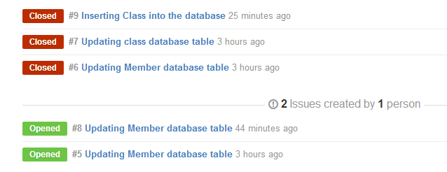

*E.g. of a GitHub’s issue tracker*

**SourceTree**

Git is completely integrated into SourceTree, the development environment that will be used for the project. It integrates all of Git’s functionality in a way that is quite simple to use.

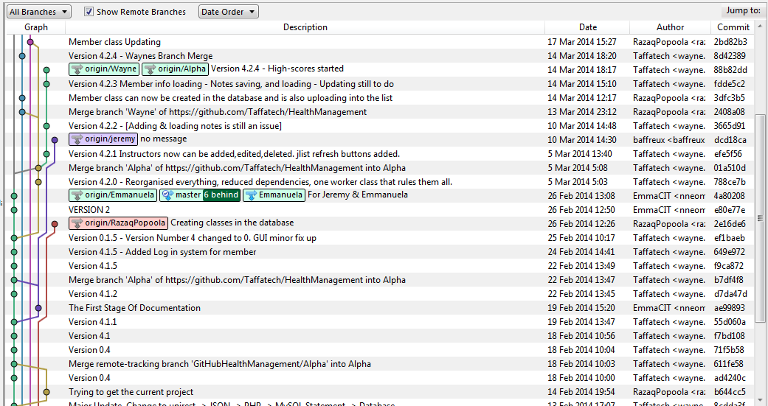

*E.g. of Commits and branches in sourceTree’s history view*

**Life cycle**

Firstly, the development of the application will undertake an iterative/prototype development based approach. One of the greatest aspects of using this model is that, anyone can see the development of the software on a step by step scale. The whole process is iterative and will make it easy to demonstrate things even when some the materials are temporary, it will be easy to change and upgrade.

Additionally, both incremental and iterative model are main procedures in the chosen methodology, which will be used in the development cycle of the Diabetes Management System. Underlying features required will be developed in separate branches, tested, and then merged when it is suitable to be integrated into the main branch.

To sum up what needs to be done, it closely relates to the iterative and incremental model.

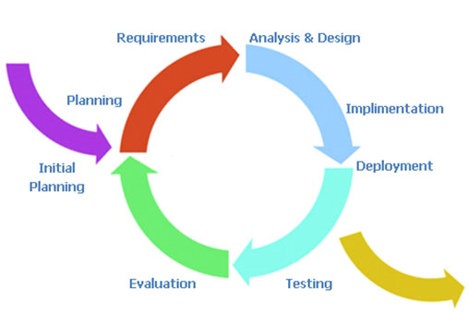

Also, the model will allow for the addition of new features to be added quickly and easily.

For a specific instance of this process above, the primary GUI components will be considered: the tabs that will be used to manipulate information in the database.

In order to begin, the requirements laid out in the report will be used. It will provide designs for the appearance and general functionality of each tab. The functional requirements will determine what is required to be done at a finer level of detail.

Branches for each tab will be created and implemented. Multiple tabs will be developed simultaneously in different branches. When each tab is completed and tested in isolation, the related branch will be merged into the master branch and integration testing will be carried out. If by any chance, there are commonalities in the work, various classes will be created to reduce redundancy and simplify development on each of the iteration. As a result of iterative prototyping and incremental improvement, there will be practically no code redundancy in the program. The design is quite elegant, featuring many reusable components.

A complete history of all development activity will be visible on the Git repository on GitHub, line by line.

**Other Tools include:**

1. XAMPP

XAMPP is a free and open source cross-platform web server solution stack package. It consists of the following components such as **Apache HTTP Server, MySQL database, PHP Programming Language, Perl Programming Language, FTP Server** and **SMTP Server**.

For the development of the website, the latest version of XAMPP, will be downloaded and installed. By using XAMPP, it helps the installation process of the named components to be quick and easy. For instance, installing the components individually, factors such as PHP configuration and the setup of MySQL will not have to be considered.

1. PHP

PHP is a general-purpose scripting language that is useful for web-development. It is used to enhance webpages. And, it is a server-side scripting language whereby the PHP code isn’t executed on the user’s computer rather; it is executed on the computer in which the user requested the PHP pages from. As a result, the pages are retrieved and displayed on the user’s web-browser.

1. HTML5

HTML5 will be used in the development of the project. HTML5 is a core technology markup language of the Internet used for structuring and presenting content for the World Wide Web (www). It is the final and complete fifth version of the HTML standard of the World Wide Web Consortium (W3C).

1. CSS

CSS (Cascading Style Sheets) is a style sheet language, which will be used for describing the look and formatting of a document written in a markup language.

1. Visual Paradigm

Visual Paradigm will be used to model the use cases and domain model of the application. It is a software design tool tailored for agile software projects. Also, it supports BPMN, UML, DFD, ERD, and SysML. Visual Paradigm will be used to draw the Use Case diagrams, and the Domain Model of the Diabetes Management System.

1. Pencil

Pencil is a free and open-source GUI prototyping tool that people can easily install and use to create mock-ups in popular desktop platforms. It will be used to mock-up the graphical user interface (GUI) design of the Diabetes Management System.

* 1. **USER INTERFACE DESIGN**

The primary interface is a web application for Google Chrome, Mozilla Firefox, Opera, and Internet Explorer.

* + 1. **Patient User Interface Design**

1. **Log into System**

At first visit to the Diabetes Management System, the patient is presented with a Login panel.

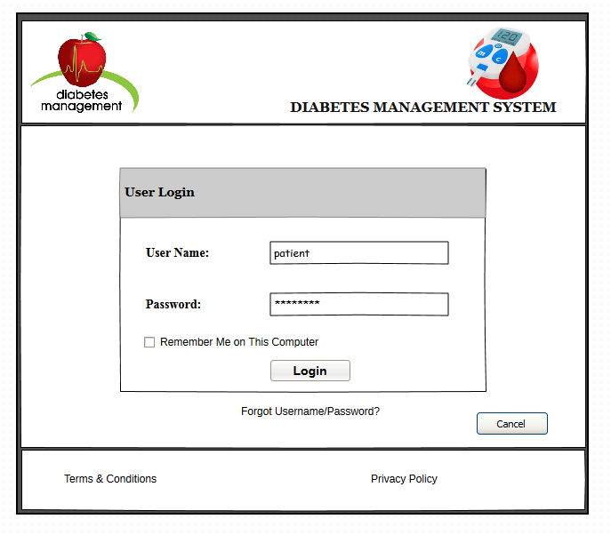

1. **Update Personal Information**

This user interface allows the patient, Doctor, and Nurse to update their profile information.

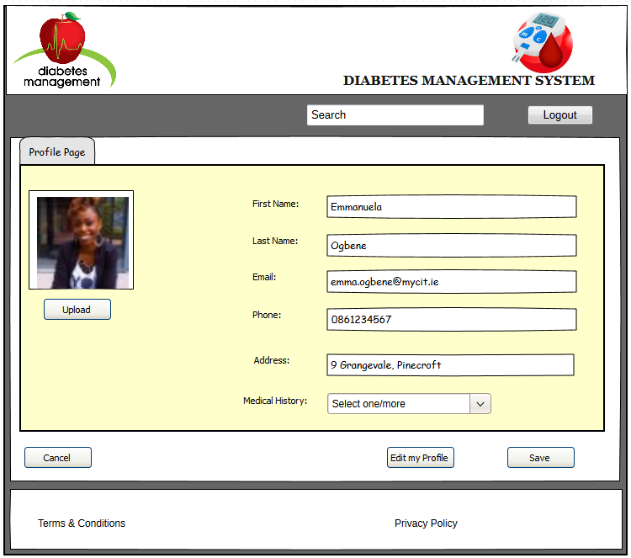

1. **View Personal Information**

This user interface allows the patient, Doctor, and Nurse to view their profile information.



1. **Record Blood Glucose Level**

This user interface allows the patient to record their blood glucose level (mmol/l) in the Diabetes Management System.

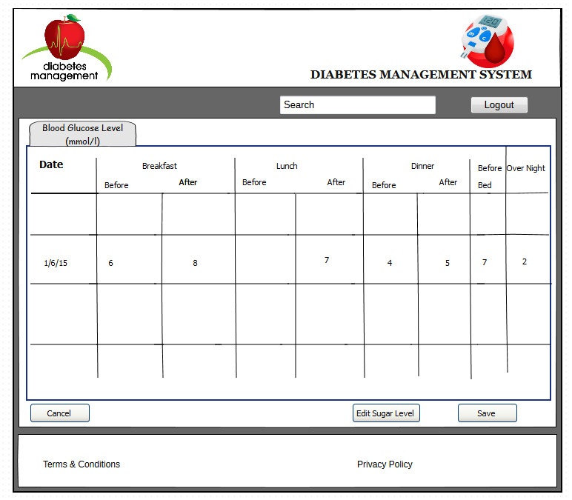

1. **Record Insulin Doses**

The user interface **“Insulin Dose”** allows the patient to record their Insulin Doses in the Diabetes Management System.

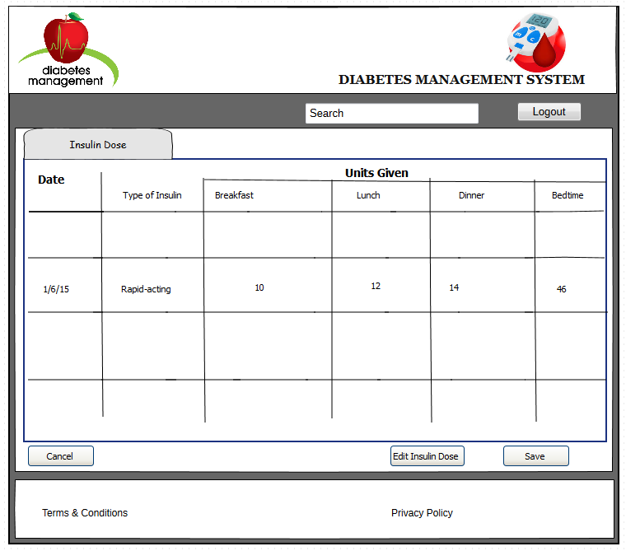

1. **Leave Personal Notes**

The user interface tab **“Leave Personal Notes”** allows the patient to leave personal notes/drafts, appointment dates, and emergency contacts, in the Diabetes Management System.

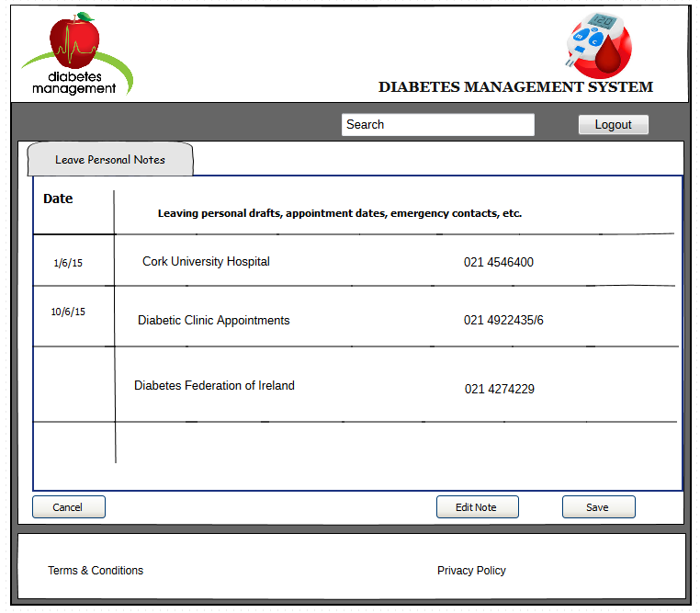

1. **Leave Comments**

The user interface tab **“Special Events/Comments”** allows the patient to leave comments based on their blood glucose level results.

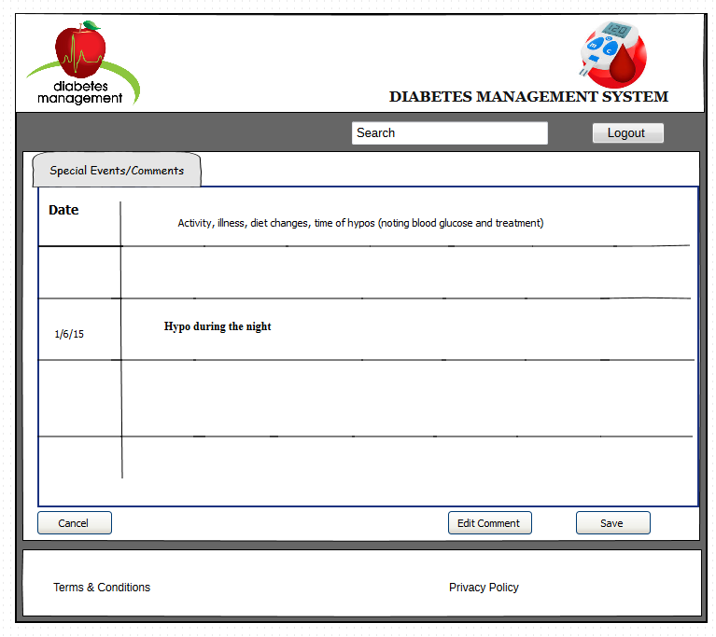

* + 1. **Administration User Interface Design**

1. **Log into System**

At first visit to the Diabetes Management System, the Doctor, Nurse and Secretary is presented with a Login panel.

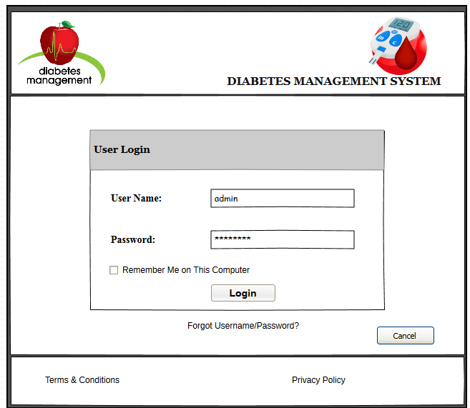

1. **View Patient Blood Glucose Level Measurements**

The user interface tab **“View Patient Blood Glucose Level Measurements (mmol/l)”** allows the Doctor to view Patient’s Blood Glucose Tests.

The Doctor will be able to see their patient’s blood glucose level performance and be able to notify them if there is a problem such as the blood glucose level is not stable (i.e. by using the **traffic light** signals).

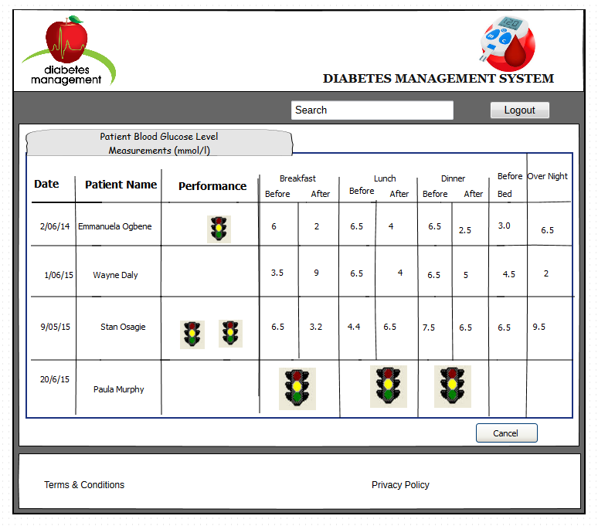

1. **Register Patients**

The user interface tab **“Register Patients”** allows the Doctor to register Patients into the Diabetes Management System.

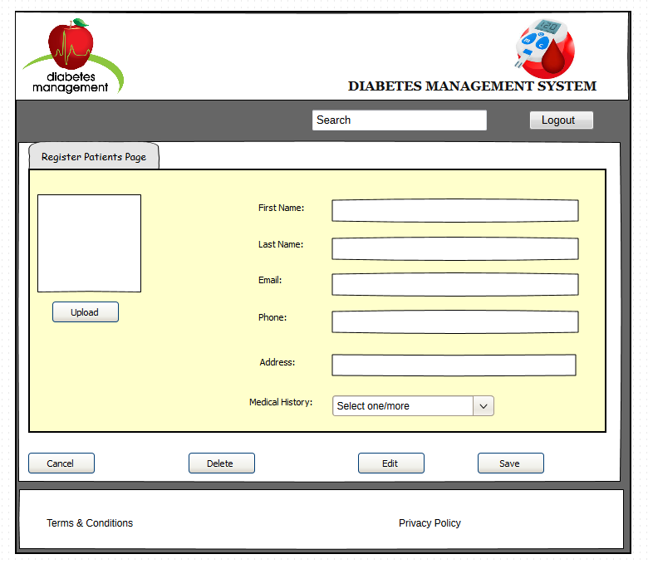

1. **Make Adjustments**

The user interface tab **“Make Adjustments”** allows the Doctor to regulate Patient’s Insulin Doses if applicable.

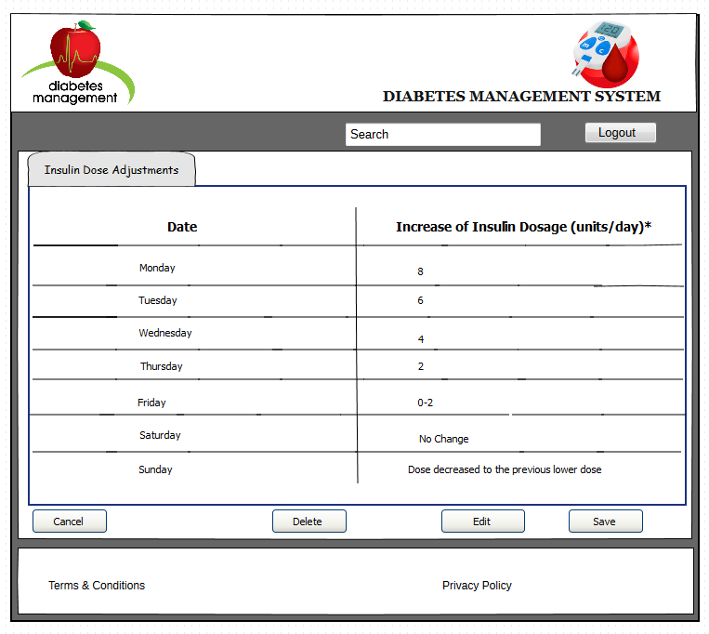

1. **Notify Patients**

The user interface tab **“Notify Patients”** allows the Doctor to send an email to his/her Patients considering the blood glucose level test results. With the email, the patient can be able to make an appointment to come in for check-ups.

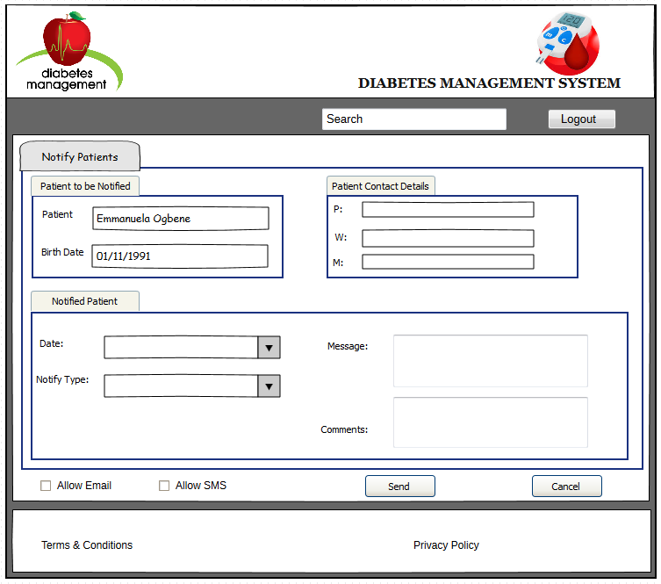

1. **Maintain Reports**

The user interface tab **“Maintain Reports”** allows the Doctor to print a report of the following instances: record of **Patients’ Blood Sugar Readings**, record of **Insulin** **Adjustments**, record of **Blood Pressure**, **Patients Personal** **Information** and list of **Insulin Doses.**

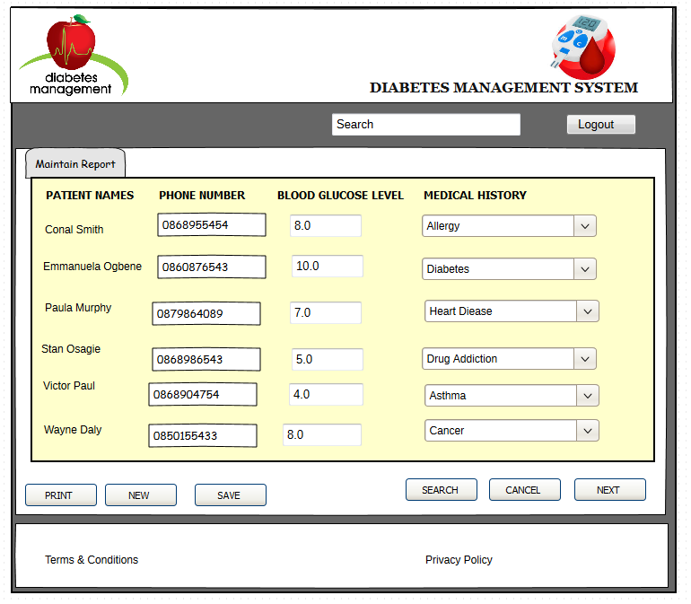

1. **PROJECT PLAN**

The purpose of the project is to develop an online application (also known as a web-based application) where both the patients and doctors can monitor the blood glucose (sugar) level readings of a glucose meter.

The Diabetes Management System (DMS) will assist in the management of diabetes. It will provide a means of tracking, organising, and managing all of the activities involved in the monitoring of diabetes. DMS will work in parallel with the existing paper-based system, which will make it possible to track patient’s data stored in the paper-based system i.e. the Diabetes Monitoring Diary.

* 1. **WORK BREAK DOWN STRUCTURE: GANTT CHART**

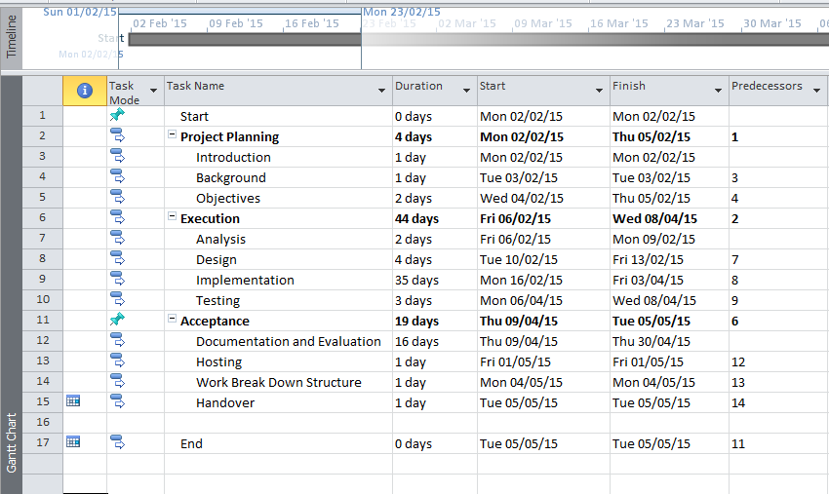

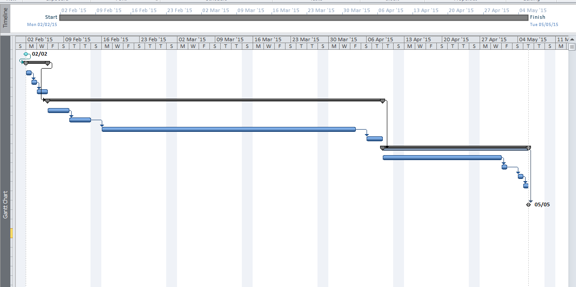

1. **CONCLUSIONS**

In conclusion, diabetes is a very serious disease. The reason is that, the body loses its ability to control the level of glucose (sugar) in the blood. Patients with diabetes control their diabetes by controlling what they eat, checking their blood glucose (sugar) several times a day, and most of all by exercising. However, if diabetes is not controlled, diabetes can lead to serious complications such as blindness, kidney failure, amputations, and can even lead to death. Additionally, it is easier to prevent diabetes than to treat it, as it is said; “**Prevention is better than cure”**.

Diabetes can be prevented or delayed by:

* Losing excess weight and belly fat, if the individual is overweight.
* Becoming more active.
* Eating healthy.
* Reducing your blood pressure if it is high.
* Lowering your blood sugar level if you have pre-diabetes.

Therefore, by adopting to these lifestyle changes, people with diabetes will be able to lower their risk of developing diabetes and its serious complications. Moreover, a prevention plan can help in reducing the risks for diabetes and heart disease while helping the individual to enjoy a healthier lifestyle.

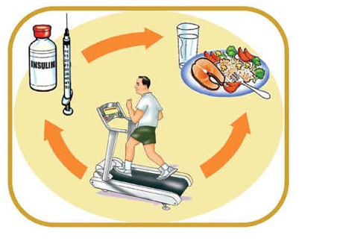

Furthermore, the Diabetes Management System (DMS) will assist in the management of diabetes. It will provide a means of tracking, organising, and managing all of the activities involved in the monitoring of diabetes. DMS will work in parallel with the existing paper-based system, which will make it possible to track patient’s data stored in the paper-based system i.e. the Diabetes Monitoring Diary. The diabetes management system will provide an easy to use GUI (Graphical User Interface) containing all the features of the system. Most importantly, provide a helpful **user-manual** for the end-users.

In summary, the Diabetes Management System (DMS) will help in the management of the following use cases:

* The creating/updating/deleting of patients in the system.
* The tracking of all patients’ information.
* Recording appointment date and time for the patients to come in for check-ups.
* Enabling doctors to print blood sugar level reports, insulin injection details, patients’ blood pressure records, changes to patient’s insulin doses, and the blood glucose testing statistics.
* Charts prepared to look for patterns and improve insulin delivery.
* Sending registration information to patients via email.
* Enabling patients to leave comments and personal notes.

# **BIBLIOGRAPHY**

American Diabetes Association, (2015). Complications. [online] Available at: <http://www.diabetes.org/living-with-diabetes/complications/> [Accessed 6 Jan. 2015].

American Diabetes Association, (2015). Statistics About Diabetes. [online] Available at: <http://www.diabetes.org/diabetes-basics/statistics/> [Accessed 6 Jan. 2015].

Diabetes Ireland, (2015). Managing Your Diabetes - Diabetes Ireland. [online] Available at: <http://www.diabetes.ie/living-with-diabetes/living-type-1/managing-diabetes/> [Accessed 6 Jan. 2015].

Diabetes.niddk.nih.gov, (2015). Causes of Diabetes. [online] Available at: <http://diabetes.niddk.nih.gov/dm/pubs/causes/#what> [Accessed 6 Jan. 2015].

Glooko.com, (2015). Glooko | Mobile Diabetes Management | Blood Glucose Log. [online] Available at: <https://glooko.com/> [Accessed 6 Jan. 2015].

Healthline.com, (2015). The 11 Best Diabetes iPhone & Android Apps of 2014. [online] Available at: <http://www.healthline.com/health-slideshow/top-iphone-android-apps-diabetes#2> [Accessed 6 Jan. 2015].

Healthline.com, (2015). The 11 Best Diabetes iPhone & Android Apps of 2014. [online] Available at: <http://www.healthline.com/health-slideshow/top-iphone-android-apps-diabetes#2> [Accessed 6 Jan. 2015].

Intelihealth.com, (2015). Health Problems That Diabetes Can Cause - Intelihealth. [online] Available at: <http://www.intelihealth.com/article/health-problems-that-diabetes-can-cause> [Accessed 6 Jan. 2015].

Mayoclinic.org, (2015). Blood glucose meter: How to choose - Mayo Clinic. [online] Available at: <http://www.mayoclinic.org/diseases-conditions/diabetes/in-depth/blood-glucose-meter/art-20046335?pg=1> [Accessed 6 Jan. 2015].

Melissa Conrad St&ouml;ppler, M. (2015). Diabetes (Type 1 and Type 2) Symptoms, Causes, Treatment - What is diabetes? - MedicineNet. [online] MedicineNet. Available at: <http://www.medicinenet.com/diabetes_mellitus/page2.htm#what_is_diabetes> [Accessed 6 Jan. 2015].

Nuigalway.ie, (2015). November 2012, New Diabetes Research Centre for the West : About Us, NUI Galway. [online] Available at: <http://www.nuigalway.ie/about-us/news-and-events/news-archive/2012/november2012/new-diabetes-research-centre-for-the-west-.html> [Accessed 6 Jan. 2015].

Roshdypharmacies.com, (2015). Preventing Diabetes. [online] Available at: <http://www.roshdypharmacies.com/healthcare-details.php?HC_ID=112> [Accessed 8 Jan. 2015].

Visual-paradigm.com, (2015). Creating class diagrams in Visual Paradigm. [online] Available at: <http://www.visual-paradigm.com/support/documents/vpuserguide/94/2576/7190_creatingclas.html> [Accessed 6 Jan. 2015].